**Chapter 2: Periodic Orbits**

Let $ϕ\left(t;x_{0}\right)$ be the solution of the differential equation $\dot{x}=F\left(x\right)$. A point $x_{0}$ is said to be a periodic point of period $T$ such that $ϕ\left(T;x_{0}\right)=x_{0}$, but $ϕ\left(t;x_{0}\right)≠x_{0}$ for $0<t<T$. If $x_{0}$ is periodic with period $T$, then the set of all point $\left\{ϕ\left(t;x_{0}\right):0≤t≤T\right\}$ is called *periodic orbit* or *closed orbit*.

Periodic orbits in the plane can either be contained in a band of periodic orbits, or they can be isolated in the sense that nearby orbits are not periodic. An isolated periodic orbit is called *limit cycle*. A limit cycle is an isolated periodic orbit for a system of differential equations in the plane. On each side of a limit cycle, the other trajectories can be either spiraling in toward the periodic orbit or spiraling away from it.

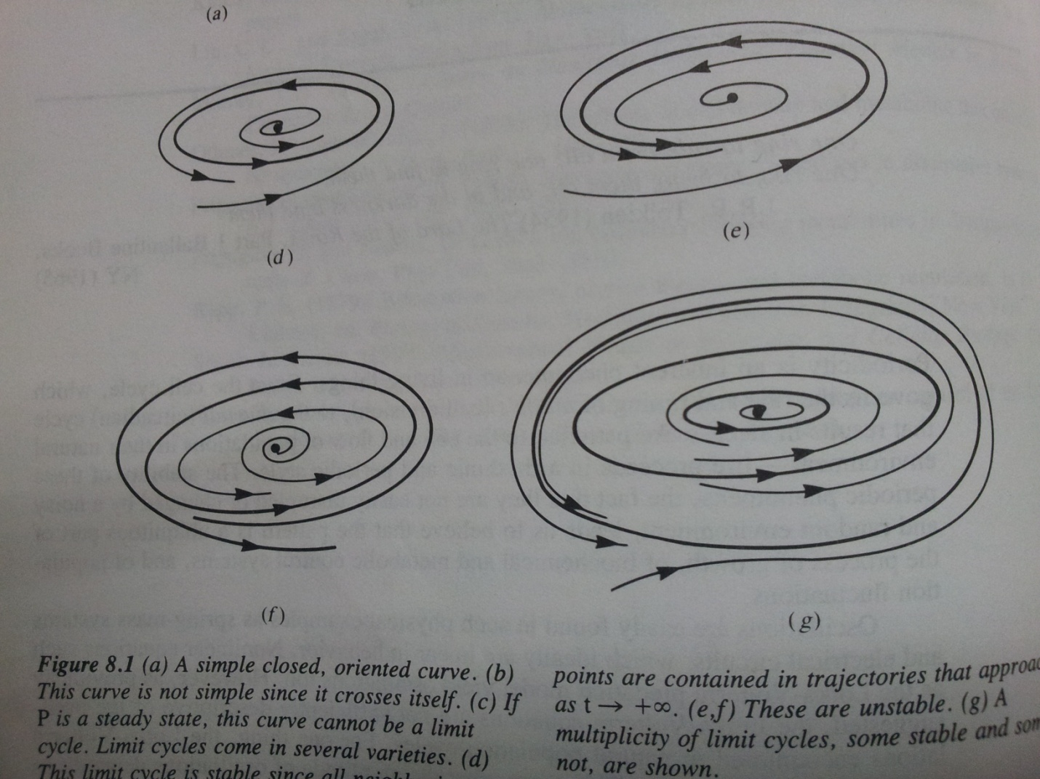

If trajectories on both sides are spiraling in, then the periodic orbit is attracting or orbitally asymptotically stable. If trajectories are both spiraling away, then the periodic orbit is repelling. If trajectories from one side of is spiraling towards it and repelling from the other side, the periodic orbit is orbitally unstable and is called semi stable.

Examples of limit cycles:

1. Van de Pol obtained the differential equation

$$\ddot{x}+ϵ\left(x^{2}-1\right)\dot{x}+x=0$$

to describe the phenomenon where triode vacuum tube was able to produce stable self-excited oscillations of constant amplitude. The equation can be written as a system of first order autonomous differential equations in the plane

$$\begin{matrix}\dot{x}=y \\ \dot{y}=-x-ϵ(x^{2}-1)y\end{matrix}$$

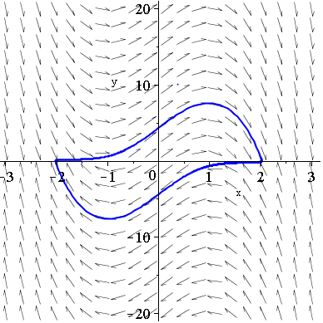

1. Example of differential equation derived by Rayleigh describing oscillation of a violin string

$$\ddot{x}+ϵ\left(\frac{{(\dot{x})}^{2}}{3}-1\right)\dot{x}+x=0$$

Which can be written as a system of first-order autonomous differential equations in the plane

$$\dot{x}=y$$

$\dot{y}=-x-ϵ\left(\frac{y^{2}}{3}-1\right)y$

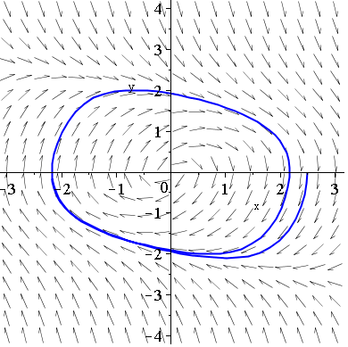

The most famous class of differential equations that generalize example (1) above are those first investigated by Lienard in 1928,

$$\ddot{x}+f(x)\dot{x}+g(x)=0$$

or in the phase plane

$$\dot{x}=y$$

$\dot{y}=-g(x)-f(x)y$

1. The differential equations

$$\dot{x}=y+x(1-x^{2}-y^{2})$$

$\dot{y}=-x+y(1-x^{2}-y^{2})$

can be written in polar coordinates

chap2_ex3.wmf

1. Describe some of the features for the following set of polar differential equation

$\dot{r}=r\left(1-r\right)\left(2-r\right)(3-r)$

$\dot{θ}=-1$

**2.1 Poincar $e^{'}$-Bendixson Theorem**

**Theorem:** Suppose that a forward orbit $\left\{ϕ\left(t;q\right):t≥0\right\}$ is contained in a bounded region in which there are finitely many critical points. Then the , $ω(q)$ is either

* A single critical point;
* A single closed orbit;
* A graphic – ciritical points joined by heteroclinic orbirts.

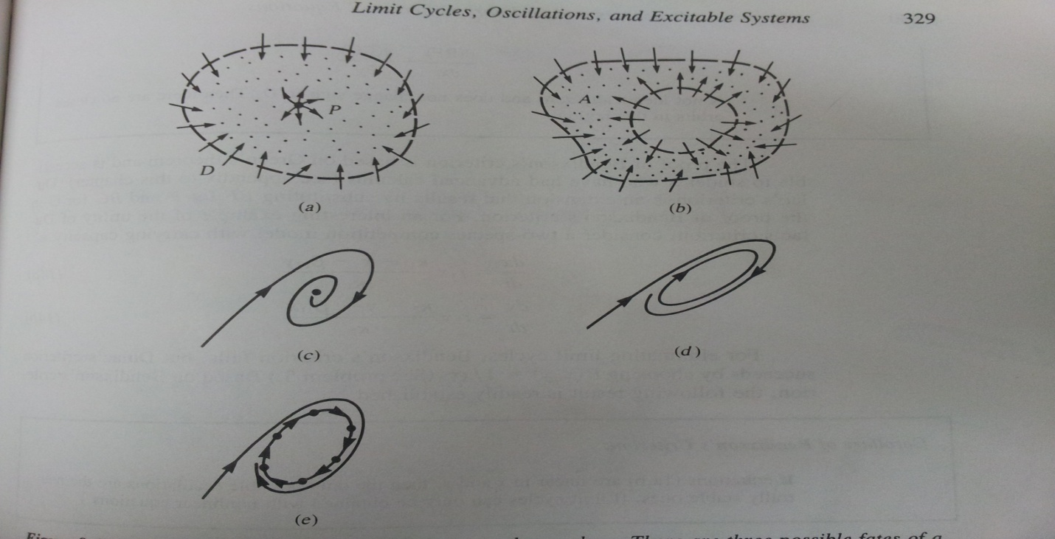

**Theorem**: (Poincar $e^{'}$-Bendixson Theorem) Consider a differential equation

$\dot{x}=F\left(x\right),$ $x∈R^{2}$

1. Assume that $F$ is defined on all of $R^{2}$**.** Assume that a forward orbit $\left\{ϕ\left(t;q\right):t≥0\right\}$ is bounded. Then, $ω(q)$ either

(i) contains a fixed point or

(ii) is a periodic orbit.

1. Assume that $A$ is a closed (includes its boundary) and bounded subset of $R^{2}$ that is positively invariant for the differential equation. We assume that $F\left(x\right)$ is defined at all points of $A$ and has no fixed point in $A$. Then, given any $x_{0}$ in $A$, the orbit $ϕ\left(t;x_{0}\right)$ is either
2. periodic or
3. tends toward a periodic orbit as $t→∞$, and $ω(x_{0})$ equals this periodic orbit.

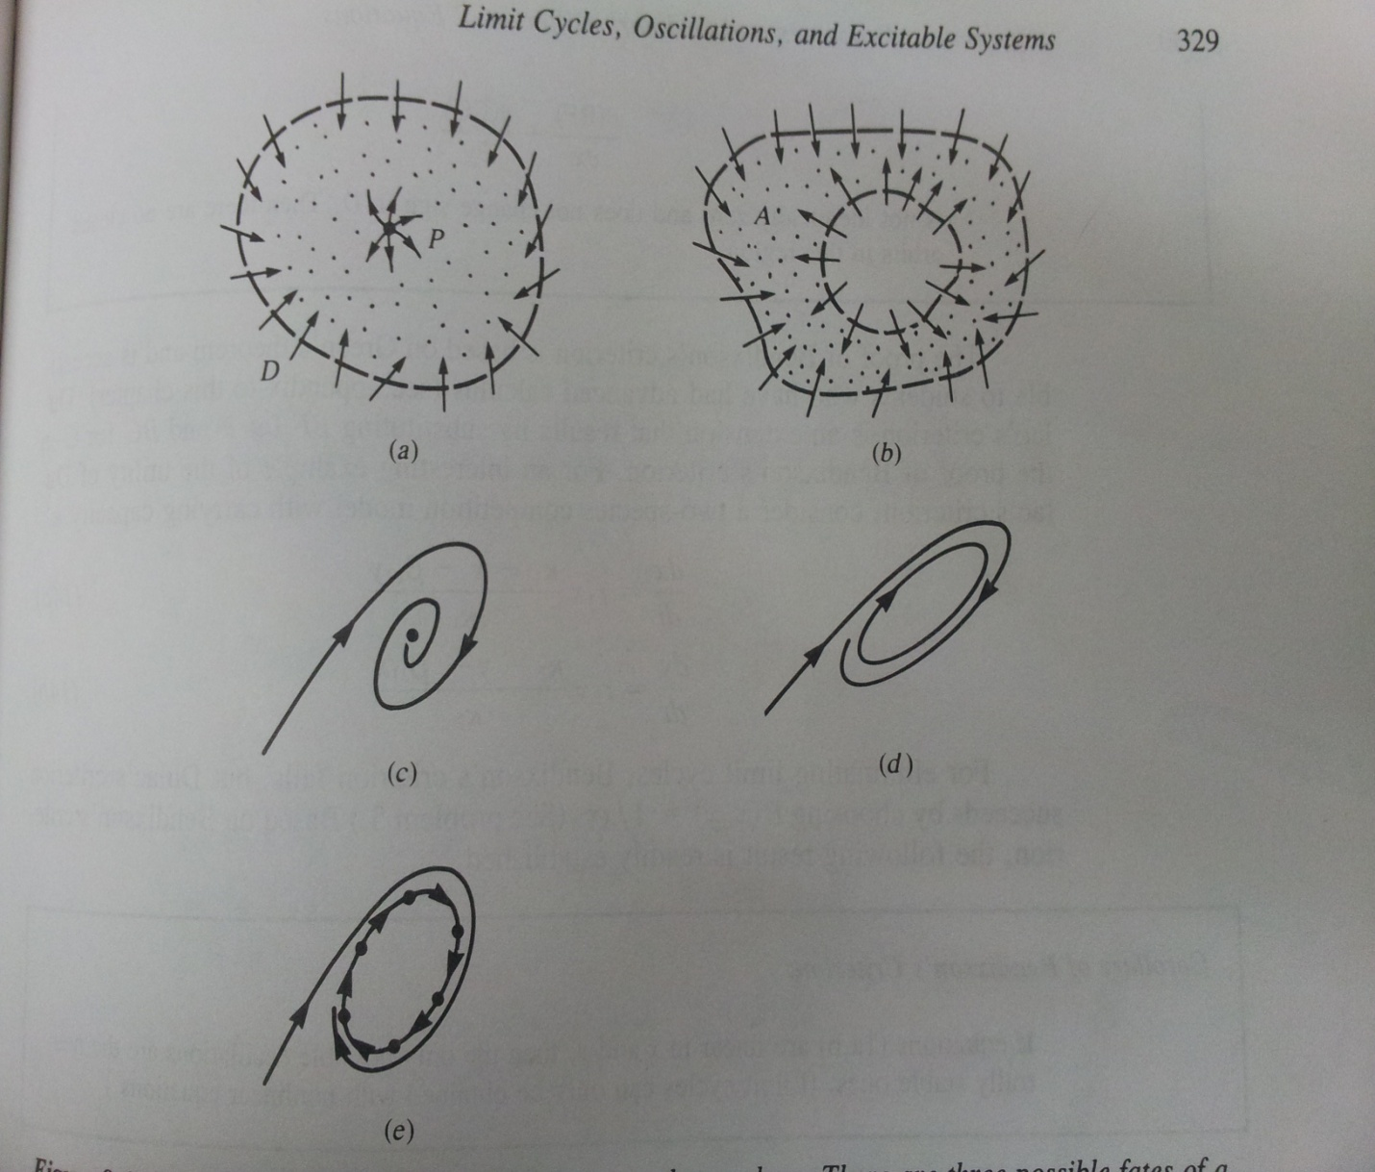

**Corollary**: Consider a differential equation $\dot{x}=F\left(x\right)$ on $R^{2}$**.** Assume that the orbit $γ$ is an isolated periodic orbit.

1. Assume that a point **p** not on $γ$ has $γ$ as its $ω$-limit set, $ω\left(p,ϕ\right)=γ$. Then, all points $q$ near enough to $γ$ on the same side of $γ$ as $p$ also have $ω\left(q,ϕ\right)=γ$. In particular, $γ$ is orbitally asymptotically stable from that one side.
2. Assume that there are points $p_{1}$ and $p_{2}$ on different side of $γ$ with $ω\left(p_{1},ϕ\right)=γ=ω\left(p_{2},ϕ\right)$. Then, $γ$ is orbitally asymptotically stable (from both sides).

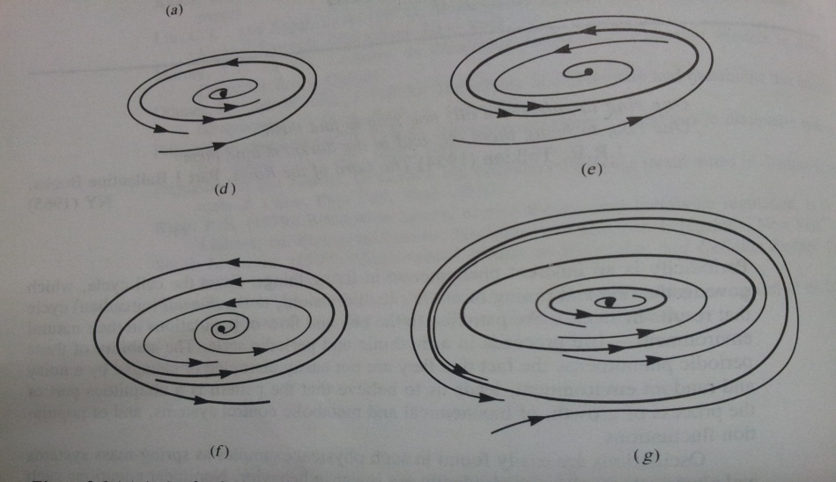

**Corollary**: Let $D$ be a bounded closed set containing no critical points and suppose that

$D$ is positively invariant. Then there exists a limit cycle contained in $D$.

*Existence of Periodic Orbits*: If you can find a region in the $xy$-plane containing a single repelling critical point (i.e unstable node or focus) and show that the trajectories along the boundary of the region never point outwards, you may conclude that there must be at least one closed periodic orbit inside the region.

Examples:

5. By considering the flow across the rectangle with corners at (-1,2), (1,2), (1,-2) and

(-1,-2), prove that the following system has at least one limit cycle.

6. By considering the flow across the square with coordinates at (1,1), (1,-1), (-1,1) and

(-1,-1), centered at the origin, prove the system

$$\dot{x}=-y+x\cos{(πx)}$$

$\dot{y}=x-y^{3}$

has a stable limit cycle.

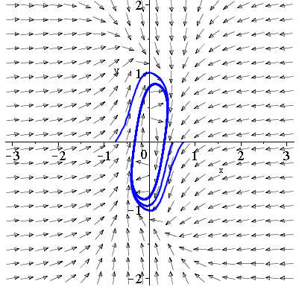

Example 5

**Definition**: A planar simple closed curve is called a *Jordon curve*.

Consider the sytem

$$\dot{x}=P(x,y)$$

$$\dot{y}=Q(x,y)$$

where $P$ and $Q$ have continuous first-order partial derivatives.

**Green’s Theorem**: Let $C$ be the Jordon curve of a finite length. Suppose that $P$ and $Q$ are two continuous differentiable functions defined on the interior of $C$, say $D$. Then

$$\iint_{D}{\left[\frac{∂P}{∂x}+\frac{∂Q}{∂y}\right]dxdy}=\oint_{C}{P\left(x,y\right)dy-Q\left(x,y\right)dx}$$

The following criteria are sometimes useful in ruling out the presence of a limit cycle, and for this reason have been called the *negative criteria*.

**Bendixson’s Criteria**: Suppose $D$ is a simply connected region of the plane (no holes in $D$). If the expression

$$\frac{∂P}{∂x}+\frac{∂Q}{∂y}$$

is not identically zero and does not change sign in $D$, then there are no closed orbits in this region.

**Dulac’s criteria**: Suppose $D$ is a simply connected region of the plane, and suppose there exists a function $B(x,y)$, continuously differentiable on $D$, such that the expression

$$\frac{∂(BP)}{∂x}+\frac{∂(BQ)}{∂y}$$

is not identically zero and does not change sign in $D$, then there are no closed orbits in this region.

**Definition**: Suppose there is a compass on a Jordon curve $C$ and that a needle points in the direction of the vector field. The compass is moved in a counter-clockwise direction around the Jordon curve by $2π$ radians. When it returns to its initial position, the needle will have moved through and angle, say $Θ$. The *index*, say $I_{x}(C)$ is defined as

$$I_{x}(C)=\frac{ΔΘ}{2π}$$

where $ΔΘ$ is the overall change in the angle $Θ$.

The above definition can be applied to isolated critical points. For example, the index of a node, focus or center is +1 and the index of a saddle is -1.

**Theorem**: The sum of indices of the critical points contained entirely within a limit cycle is +1.

**Theorem**: A limit cycle contains at least one critical point.

When proving that a system has no limit cycles, the following items should be considered.

1. Bendixson’s criteria or Dulac’s criteria
2. Indices
3. Invariant lines
4. Critical points.

Examples: Prove that none of the following systems have any limit cycles:

7. $\dot{x}=1+y^{2}-e^{xy}$

$\dot{y}=xy+\cos^{2}y$

The system has no critical points and hence, no limit cycles

8. $\dot{x}=y^{2}-x$

$\dot{y}=y+x^{2}+yx^{3}$

The critical point is at the origin and it is a saddle (index -1)

9. $\dot{x}=y+x^{3}$

$\dot{y}=x+y+y^{3}$

The divergence $\frac{∂P}{∂x}+\frac{∂Q}{∂y}=3x^{2}+1+3y^{2}≠0$

10. $\dot{x}=x(2-y-x)$

$\dot{y}=y(4x-x^{2}-3)$, given $B\left(x,y\right)=\frac{1}{xy}$