DEVELOPMENT OF VERTICAL TAKE-OFF AND LANDING AIRCRAFT

NUR ^%*&%* *&%* BINTI AZMI

UNIVERSITI TEKNOLOGI MALAYSIA

PSZ 19:16 (Pind. 1/13)

UNIVERSITI TEKNOLOGI MALAYSIA

DECLARATION OF THESIS / UNDERGRADUATE PROJECT REPORT AND COPYRIGHT

Author’s full name :

Date of Birth :

Title :

Academic Session :

I declare that this thesis is classified as:

|  |  |  |
| --- | --- | --- |
|  | CONFIDENTIAL | (Contains confidential information under the Official Secret Act 1972)* |
|  |  |  |
|  | RESTRICTED | (Contains restricted information as specified by the organization where research was done)* |
|  |  |  |
| ✓ | OPEN ACCESS | I agree that my thesis to be published as online open access (full text) |

1. I acknowledged that Universiti Teknologi Malaysia reserves the right as follows:
2. The thesis is the property of Universiti Teknologi Malaysia
3. The Library of Universiti Teknologi Malaysia has the right to make copies for the purpose of research only.
4. The Library has the right to make copies of the thesis for academic exchange.

|  |  |  |  |  |
| --- | --- | --- | --- | --- |
|  |  |  | Certified by: |  |
|  |  |  |  |  |
|  |  |  |  |  |
|  |  |  |  |  |
|  | SIGNATURE OF STUDENT |  | SIGNATURE OF SUPERVISOR |  |
|  |  |  |  |  |
|  | B17KM0050 |  | DR.-ING. M. NAZRI M. NASIR, CENG |  |
|  | **MATRIC NUMBER** |  | **NAME OF SUPERVISOR** |  |
|  |  |  |  |  |
|  | Date: 1 JAN 2020 |  | Date: 1 JAN 2020 |  |

NOTES : If the thesis is CONFIDENTIAL or RESTRICTED, please attach with the letter from the organization with period and reasons for confidentiality or restriction

“We hereby declare that we have read this thesis and in our

opinion this thesis is sufficient in term of scope and quality for the

award of the degree of Bachelor of Engineering (Mechanical-Aeronautics)”

|  |  |  |
| --- | --- | --- |
| Signature | : | ________________________________ |
| Name of Supervisor I | : | M. NAZRI M. NASIR |
| Date | : | 1 January 2020 |
|  |  |  |
|  |  |  |
| Signature | : | ________________________________ |
| Name of Supervisor II | : | SHUHAIMI MANSOR |
| Date | : | 1 January 2020 |
|  |  |  |

**BAHAGIAN A - Pengesahan Kerjasama\***

Adalah disahkan bahawa projek penyelidikan tesis ini telah dilaksanakan melalui

kerjasama antara ________________________dengan ________________________

Disahkan oleh:

Tandatangan : Tarikh :

Nama :

Jawatan :

(Cop rasmi)

*\* Jika penyediaan tesis atau projek melibatkan kerjasama.*

**BAHAGIAN B - Untuk Kegunaan Pejabat Sekolah Pengajian Siswazah**

Tesis ini telah diperiksa dan diakui oleh:

|  |  |  |
| --- | --- | --- |
| Nama dan Alamat Pemeriksa Luar | **:** |  |
|  |  |  |
|  |  |  |
|  |  |  |
|  |  |  |
| Nama dan Alamat Pemeriksa Dalam | **:** |  |
|  |  |  |
|  |  |  |
|  |  |  |
|  |  |  |
| Nama Penyelia Lain (jika ada) | **:** |  |
|  |  |  |
|  |  |  |
|  |  |  |
|  |  |  |

Disahkan oleh Timbalan Pendaftar di SPS:

|  |  |  |  |
| --- | --- | --- | --- |
| Tandatangan | : |  | Tarikh : |
| Nama | : |  | |

DEVELOPMENT OF VERTICAL TAKE-OFF AND LANDING AIRCRAFT

NUR AIZAT NAZIHAH BINTI AZMI

A thesis submitted in partial fulfilment of the

requirements for the award of the degree of

Bachelor of Engineering (Mechanical-Aeronautics)

School of Mechanical Engineering

Faculty of Engineering

Universiti Teknologi Malaysia

JANUARY 2020

DECLARATION

I declare that this thesis entitled *“Development of Vertical Take-Off and Landing Aircraft ”* is the result of my own research except as cited in the references. The thesis has not been accepted for any degree and is not concurrently submitted in candidature of any other degree.

|  |  |  |
| --- | --- | --- |
| Signature | : | .................................................... |
| Name | : | NUR AIZAT NAZIHAH BINTI AZMI |
| Date | : | 1 January 2020 |
|  |  |  |
|  |  |  |

DEDICATION

This thesis is dedicated to my father, who taught me that the best kind of knowledge to have is that which is learned for its own sake. It is also dedicated to my mother, who taught me that even the largest task can be accomplished if it is done one step at a time.

ACKNOWLEDGEMENT

In preparing this thesis, I was in contact with many people, researchers, academicians, and practitioners. They have contributed towards my understanding and thoughts. In particular, I wish to express my sincere appreciation to my main thesis supervisor, Professor Dr. Mohd Shariff Nabi Baksh, for encouragement, guidance, critics and friendship. I am also very thankful to my co-supervisor Professor Dr Awaluddin Mohd Shaharoun and Associate Professor Dr. Hishamuddin Jamaluddin for their guidance, advices and motivation. Without their continued support and interest, this thesis would not have been the same as presented here.

I am also indebted to Universiti Teknologi Malaysia (UTM) for funding my Ph.D study. Librarians at UTM, Cardiff University of Wales and the National University of Singapore also deserve special thanks for their assistance in supplying the relevant literatures.

My fellow postgraduate student should also be recognised for their support. My sincere appreciation also extends to all my colleagues and others who have provided assistance at various occasions. Their views and tips are useful indeed. Unfortunately, it is not possible to list all of them in this limited space. I am grateful to all my family member.

ABSTRACT

The purpose of this study is to investigate the application of genetic algorithm (GA) in modelling linear and non-linear dynamic systems and develop an alternative model structure selection algorithm based on GA. Orthogonal least square (OLS), a gradient descent method was used as the benchmark for the proposed algorithm. A model structure selection based on modified genetic algorithm (MGA) has been proposed in this study to reduce problems of premature convergence in simple GA (SGA). The effect of different combinations of MGA operators on the performance of the developed model was studied and the effectiveness and shortcomings of MGA were highlighted. Results were compared between SGA, MGA and benchmark OLS method. It was discovered that with similar number of dynamic terms, in most cases, MGA performs better than SGA in terms of exploring potential solution and outperformed the OLS algorithm in terms of selected number of terms and predictive accuracy. In addition, the use of local search with MGA for fine-tuning the algorithm was also proposed and investigated, named as memetic algorithm (MA). Simulation results demonstrated that in most cases, MA is able to produce an adequate and parsimonious model that can satisfy the model validation tests with significant advantages over OLS, SGA and MGA methods. Furthermore, the case studies on identification of multivariable systems based on real experiment t al data from two systems namely a turbo alternator and a continuous stirred tank reactor showed that the proposed algorithm could be used as an alternative to adequately identify adequate and parsimonious models for those systems. Abstract must be bilingual. For a thesis written in Bahasa Melayu, the abstract must first be written in Bahasa Melayu and followed by the English translation. If the thesis is written in English, the abstract must be written in English and followed by the translation in Bahasa Melayu. The abstract should be brief, written in one paragraph and not exceed one (1) page. An abstract is different from synopsis or summary of a thesis. It should states the field of study, problem definition, methodology adopted, research process, results obtained and conclusion of the research. The abstract can be written using single or one and a half spacing. Example can be seen in Appendix 1 (Bahasa Melayu) and Appendix J (English).

ABSTRAK

Kajian ini dilakukan bertujuan mengkaji penggunaan algoritma genetik (GA)

dalam pemodelan sistem dinamik linear dan tak linear dan membangunkan kaedah alternatif bagi pcmilihan struktur model menggunakan GA. Algorithma kuasa dua terkecil ortogon (OLS), satu kaedah penurunan kecerunan digunakan sebagai bandingan bagi kaedah yang dicadangkan. Pcmilihan struktur model mengunakan kaedah algoritma genetik yang diubahsuai (MGA) dicadangkan dalam kajian ini bagi

mengurangkan masalah konvergens pramatang dalam algoritma genetik mudah (SGA). Kesan penggunaan gabungan operator MGA yang berbeza ke atas prestasi model yang terbentuk dikaji dan keberkesanan serta kekurangan MGA diu t arakan. Kajian simulasi dilakukan untuk membanding SGA, MGA dan OLS. Dengan meggunakan bilangan parametcr dinamik yang setara kajian ini mendapati, dalam kebanyakan kes, prestasi MGA adalah lebih baik daripada SGA dalam mencari penyelesaian yang berpotensi dan lebih berkebolehan daripada OLS dalam menentukan bilangan sebutan yang dipilih dan ketcpatan ramalan. Di samping itu, penggunaan carian tcmpatan dalam MGA untuk menambah baik algorithma tersebut dicadang dan dikaji, dinamai sebagai algoritma mcmetic (MA). Hasil simulasi menunjukkan, dalam kebanyakan kes, MA berkeupayaan menghasilkan model yang bersesuaian dan parsimoni dan mcmenuhi ujian pengsahihan model di samping mcmperolehi beberapa kelebihan dibandingkan dengan kaedah OLS, SGA dan MGA. Tambahan pula, kajian kes untuk sistcm berbilang pcmbolehubah menggunakan data eksperimental sebenar daripada dua sistem iaitu sistem pengulang-alik turbo dan reaktor teraduk berterusan menunjukkan algoritma ini boleh digunakan sebagai alternatif untuk mcmperolehi model termudah yang memadai bagi sistcm tersebut.

TABLE OF CONTENTS

|  |  |  |
| --- | --- | --- |
|  | TITLE | PAGE |

TABLE OF CONTENTS i

LIST OF TABLES iii

LIST OF FIGURES iv

CHAPTER 1 INTRODUCTION 1

1.1 Background of Study 1

1.2 Problem Statement 2

1.3 Research Questions 2

1.4 Objective 3

1.5 Scope of Study 4

1.6 Significance of Study 4

CHAPTER 2 LITERATURE REVIEW 7

2.1 Unmanned Aircraft System 7

2.2 VTOL UAV 8

2.3 Basic Electronic Components in a UAV 15

2.3.1 Battery 15

2.3.2 Motor 17

2.3.3 Propeller 18

2.3.4 ESC 19

2.3.5 Receiver and Transmitter 20

2.3.6 Servo 21

2.3.7 GPS Module 22

2.3.8 Telemetry 23

2.4 Control System 24

2.4.1 Proportional Controller 25

2.4.2 Proportional-Integral Controller 26

2.4.3 Proportional-Integral-Derivative Controller 26

CHAPTER 3 METHODOLOGY 29

3.1 Introduction 29

3.2 Flow Chart 29

3.3 Reference UAV 31

3.3.1 Dimension 31

3.3.2 Mass and Balance Analysis 32

3.3.3 CG Estimation 33

3.4 Structural Analaysis 33

3.4.1 Wing Specification 33

3.4.2 Shear Force and Bending Moment Diagram 34

3.4.3 Wing Deflection Set-up 34

3.4.3.1 Preparation of the Airfoil Wing 35

3.4.3.2 Set-up for Wing Deflection Test 35

3.5 Analysis on Propulsion System 37

3.5.1 Thrust and Power Required Calculation for Fixed Wing Mode 37

3.5.2 Thrust and Power Required Calculation for Fixed Wing Mode 40

3.5.3 Subsystem Efficiency 42

3.5.4 Flight Test 42

3.6 Analysis on Control System 44

3.6.1 Preparing for Tuning Test 44

3.6.2 Tuning Test 45

CHAPTER 4 CONCLUSION 47

REFERENCES 48

LIST OF TABLES

|  |  |  |
| --- | --- | --- |
| TABLE NO. | TITLE | PAGE |

Table ‎1.1 The role of statistical quality engine

[Table 3.1 UAV Weight 32](#_Toc523259628)

[Table 3.2 Wing Specification 33](#_Toc523259628)

[Table 3.3 Deflection Table 37](#_Toc523259628)

[Table 3. 4 Subsystem Efficiency 42](#_Toc523259628)

[Table 3. 5 Result for average current consumption 43](#_Toc523259628)

LIST OF FIGURES

|  |  |  |
| --- | --- | --- |
| FIGURE NO. | TITLE | PAGE |

Figure ‎1.1 Trends leading to the proble

[Figure 2. 1 Aeroquad Quadcopter 9](#_Toc534814909)

[Figure 2. 2 James DeLaurier Jet-assisted Ornithopter 9](#_Toc534814909)

[Figure 2. 3 Bell XV 10](#_Toc534814909)

[Figure 2. 4 Vertol 76 10](#_Toc534814909)

[Figure 2. 5 Lockheed XFV 11](#_Toc534814909)

[Figure 2. 6 HQ-60 Hybrid Quadrotor UAV 11](#_Toc534814909)

[Figure 2. 7 Quadcopter ‘X’ configuration 12](#_Toc534814909)

[Figure 2. 8 Quadcopter ‘X’ configuration on conventional fixed-wing UAV 12](#_Toc534814909)

[Figure 2. 9 Lift force and weight acting on the body of the aircraft 13](#_Toc534814909)

[Figure 2. 10 Arrangement of the electronic components 15](#_Toc534814909)

[Figure 2. 11 Li-Po battery 16](#_Toc534814909)

[Figure 2. 12 Lithium-Ion battery 17](#_Toc534814909)

[Figure 2. 13 Brushed DC motor 17](#_Toc534814909)

[Figure 2. 14 Brushless DC motor 18](#_Toc534814909)

[Figure 2. 15 Propeller 19](#_Toc534814909)

[Figure 2. 16 Electronic Speed Controller 20](#_Toc534814909)

[Figure 2. 17 Transmitter and Receiver 21](#_Toc534814909)

[Figure 2. 18 Servo connected at the control surface of RC plane 22](#_Toc534814909)

[Figure 2. 19 High Precision GPS Module 23](#_Toc534814909)

[Figure 2. 20 Telemetry 24](#_Toc534814909)

[Figure 2. 21 Simple block diagram for an open loop system 24](#_Toc534814909)

[Figure 2. 22 Simple block diagram for a closed-loop system 25](#_Toc534814909)

[Figure 2. 23 Simple block diagram with K](#_Toc534814909)[P](#_Toc534814909) [gain 26](#_Toc534814909)

[Figure 2. 24 Simple block diagram with both K](#_Toc534814909)[P](#_Toc534814909) [and K](#_Toc534814909)[i](#_Toc534814909) [gain 26](#_Toc534814909)

[Figure 2. 25 PID Controller 27](#_Toc534814909)

[Figure 3.1 Flow Chart 30](#_Toc534814909)

[Figure 3.2 Quad-rotor Fixed-wing UAV Solidwork Model 31](#_Toc534814909)

[Figure 3.3 2-Dimensional Wing-Fuselage Joint 34](#_Toc534814909)

[Figure 3.4 Free body diagram 34](#_Toc534814909)

[Figure 3.5 Stationary rig holding the wing 36](#_Toc534814909)

[Figure 3.6 The detailed drawing for experimental set-up 36](#_Toc534814909)

[Figure 3.7 Graph of CL against $α$ 39](#_Toc534814909)

[Figure 3.8 Graph of C](#_Toc534814909)[D](#_Toc534814909) [against $α$ 39](#_Toc534814909)

# INTRODUCTION

## Background of Study

This undergraduate project specifically studies the hybrid VTOL aircraft, a quad-rotor fixed-wing aircraft with two sets of propulsion system. This project is carried out through two means of analysis which are the numerical calculation and experimental approach in order to find out the answers related to this project.

The definition of a VTOL aircraft is very clear and precise. A VTOL aircraft must be able to take-off, hover and land vertically without the need of a runway. Meanwhile a hybrid VTOL aircraft refers to the type of VTOL aircraft that combines the flying mechanism of both rotorcraft and fixed wing aircraft. Since a hybrid VTOL aircraft means a VTOL aircraft that is capable for both vertical and horizontal flight, it means it also capable of producing both vertical and horizontal thrust. Therefore, two sets of propulsion system mentioned in previous paragraph means that the hybrid VTOL is using two different sets of propulsion system to produce the different thrust.

The mounting of VTOL motors on the wing of the quad-rotor fixed-wing has caused the wing to change its frontal area. This issue further has affected the wing loading and also the lift experienced by the wing. By doing analysis on this issue, we will be able to know other related causes or effects for this phenomenon. Apart from that, the energy consumption of a VTOL is also important since the reference VTOL used for this undergraduate project uses two different propulsion systems. The practicality of using two sets of propulsion system instead of one need to be known so that improvement for this field can be made afterwards. Other than that, the stability of a VTOL aircraft during flying is another issue that must be focused on.

## Problem Statement

Maximizing the flying qualities of an Unmanned Aerial Vehicle or UAV is not a new topic in the aeronautical engineering branch. Even though by assimilating quad-rotor UAV with fixed-wing UAV may seem like a good solution, the fact that there will be interference of airstream between the rotor and the wing especially during transition for hybrid UAV cannot simply be ignored. Since it produces two different type of thrusts with different direction which are the horizontal and vertical thrust, there will be an overlapping of thrust during the transition, when switching flight mode from hover to forward flight and vice versa. This interference may cause the UAV to become unstable.

Other than that, the extra VTOL motors mounted at the aircraft wing increases the wing loading while simultaneously increases the lift forces also. In addition, the multiple non-operational rotors for vertical lift generation also cause extra aerodynamic drag due to their fixed mounting, resulting in additional burden to the tractors or pushers. Now the question of will there be any effects cause from the added VTOL motors to the wing deflection or not? Therefore, a quad-rotor fixed-wing UAV is believed to be the most suitable VTOL aircraft to be the centre of this study in order to investigate the answers for all the problems stated previously.

## Research Questions

a) What is the effect of VTOL motors on the vertical deflection of the wing during vertical take-off?

b) Which flying mode consumes the most energy?

c) What is the most suitable value of proportional, integral and derivative (PID) gain for the aircraft to stabilize itself during the VTOL mode?

## Objective

This undergraduate project is a numerical, analytical and empirical research on the development of VTOL aircraft. The main purpose of this project is to carry out analysis on propulsion system, body structure and control system of a VTOL aircraft. Therefore a quad-rotor fixed-wing has been chosen as the reference aircraft and all analysis is done on it.

The first objective of this project is to conduct wing deflection test to find effect of VTOL motors in terms of deformation on the wing of aircraft during take-off. So far, there has been little discussion about the effect of VTOL motors on wing vertical deflection. The effect here means to check whether will there be any significant deformation caused by the VTOL motors on the wing. This is because, during VTOL mode, a point force will exist that represents the lift force produced by the four VTOL motors.

The second objective is to carry out flight test in order to determine the highest power consumption among the VTOL and horizontal flying mode. Same as structural analysis, as weight increases, the lift required is also increase. There are two approaches to increase the lift which is structural approach and aerodynamic approach. Structural approach is where we increase the size of the wing or propeller blade while aerodynamic approach is where we increase the power used.

Lastly, the third objective is to determine the suitable PID controller for this aircraft. As mentioned previously, there is an overlapping of thrust occur during transition. This overlapping thrust acts as perturbation to the aircraft in which causes the aircraft to become unstable. The problem now is how long does it take for the aircraft to back to its original horizontal position? Therefore tuning test is carried out to determine the suitable value of PID gain.

## Scope of Study

Due to the limited time set by the faculty to finish this undergraduate project, therefore several constraints have been set to limit the study. The first area of research that is covered by this undergraduate project is that a quad-rotor fixed-wing VTOL UAV used has a total weight of not more than 4kg. This weight includes the payload and several other electronics components.

The second limitation is that this study will only focus on two sets of propulsion systems instead of one hence tiltrotor, tiltwing and tailsitter is not valid for this undergraduate project. In addition, the source of power that is used in this UAV must be batteries instead of fuel or solar power since the cost of using batteries is much less than using fuel and at the same time much easier to get as compared to the solar power.

Lastly, the number of motors used on the aircraft are five in which four of them are the VTOL motors and an extra pusher will be mounted at the front part of the fuselage. The four VTOL motors acts as the lift generator during VTOL while the pusher is used to produce thrust for horizontal flying condition.

## Significance of Study

Based on the research carried out for this undergraduate project, the weakness of a quad-rotor fixed-wing UAV can be identified and hence improvement can be made afterwards. This type of VTOL actually has the potential to become an air taxi due to its advantages of being able to take-off and landing vertically and having high endurance. This is because, an air taxi is most suitable for people in urban area where the road is always packed with vehicles and at the same time people is running out of time to run their errands.

However, due to the limited space in urban area, therefore a conventional airplane that needs a long runway and big space to take off and land is not suitable. That is why, if this topic is being carefully studied and developed, it may be a stepping stone for mankind to dominate the air. Other than that, the result of this study is also hoped to benefit anybody, from aeronautical engineering students to the community that currently is focusing on the development of this type of UAV.

# LITERATURE REVIEW

## Unmanned Aircraft System

UAS or unmanned aircraft system is a system that consists of an unmanned air vehicle (UAV), the weight or payload that the UAV carry and any kind of system that is related to the flight of the UAV such as control systems which include the remote station (Austin, 2010).

UAV represents radio controlled aircrafts and are normally used for autonomous operation (Abd Rahman et. al, 2018). Among the usage of UAV in real life application other than in military include reconnaissance, SAR operation or Search and Rescue, wildlife research and agriculture operations such as spraying insecticides, measuring trees in large plantation and sowing seed.

There are initially two main types of UAV which are fixed-wing UAV and rotor-wing UAV (Gunarathna and Munasinghe, 2018; Abd Rahman et. al, 2018; Saeed et. al, 2018). Each of this type has its own limitations and advantages on payload, endurance, range of flight and cruising speed. The higher endurance and longer flight range is among the advantages of a fixed-wing UAV but this type of UAV still needs a long runway or spacious space for taking off and landing (Abd Rahman et. al, 2018). Meanwhile the rotorcraft UAV has higher maneuverability and is capable of VTOL but has much lesser speed and lower endurance (Gunarathna & Munasinghe, 2018; Saeed et al., 2018).

However, the high interest to develop a UAV that is capable to tackle both limitations stated earlier and possessed a high flying quality has led to the innovation of a hybrid UAV which assimilate the advantages of fixed-wing and rotorcraft UAV.

## VTOL UAV

A vertical take-off and landing aircraft is an aircraft that is capable to take-off, hover and land vertically (Kohlman , 1981). Other than that, VTOL ircraft is also defined as an aircraft that can take off and land from one fixed position without requiring a long runway (Intwala and Parikh, 2015). Here we can see that both definitions basically bring one same meaning which is describing an aircraft or airship that does not use the conventional way of taking off and landing. It is indeed a direct and precise meaning from the abbreviation VTOL.

VTOL is not a new topic in the field of aeronautical engineering because there are proceedings, papers and researces dated since 1950s regarding VTOL aircrafts (Kohlman , 1981). However, among any other subdivisions in aeronautical engineering, VTOL stays as one of the most exciting and challenging topic to deal with.

There are three main categories that fall under the VTOL aircraft which are rotorcraft, ornithopter and fixed-wing VTOL (Saeed et. al, 2018).

The most common example for rotorcraft is helicopter. A helicopter is a type of aircraft that uses blades of propeller to generate lift (Jothi, 2004). The blades will rotate about vertical or almost vertical axis and hence producing lift force that enables the aircraft to fly. Other than helicopter, the multicopter such as quadcopter (as shown in Figure 2.1), bicopter are also one of the rotorcraft aircrafts.

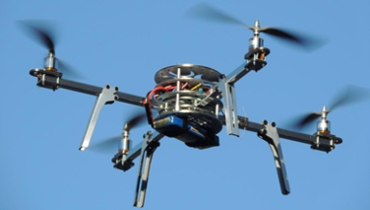

Figure 2. 1 Aeroquad Quadcopter

Another special type of VTOL aircraft is the ornithopter or the flapping wing aircraft. An ornithopter as presented below uses the mechanism of the insects or birds wing to produce lift by flapping their wings (Gerdes and Gupta, 2012). This type of VTOL aircraft is the most suitable for reconnaissance mission.

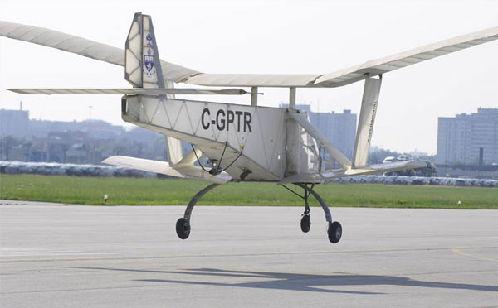

Figure 2. 2 James DeLaurier Jet-assisted Ornithopter

A hybrid UAV is categorized into two types which are the one that has one set of propulsion system and another one is the one that has two propulsion systems. Tielin et. al, 2017). One propulsion system refers to the aircraft that use one propulsion system only for both hovering and forward flight. The obvious example for this type of hybrid UAV is the tiltwing and tiltrotor. The second type of UAV that uses two different types of propulsion system is because one is used for generating lift for VTOL while the other one is used for forward flight. The example for this type of hybrid UAV is quad-rotor fixed-wing UAV.

Next is the tiltrotor aircraft. A tiltrotor aircraft is an aircraft that rotates or tilts its horizontal thrust producer until it becomes vertical. The thrust then produce airjet that push downwards. As a result, lift force will be produced then. Meanwhile a tiltwing aircraft will rotate its wing so that the engine mounted at the wing will be in vertical position to enable it to take-off vertically (McCornick, 1967). In short, the tiltrotor and tiltwing basically have the same propulsion system for cruising and VTOL. The example of tiltrotor is displayed in Figure 2.3 while tiltwing is as displayed in Figure 2.4 (McCornick, 1967).

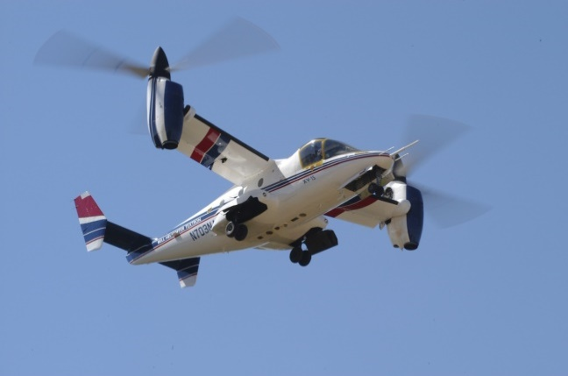

Figure 2. 3 Bell XV

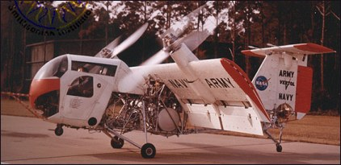

Figure 2. 4 Vertol 76

As for the tailsitter, it is an aircraft that takes off on its tail. A tailsitter aircraft does not necessarily need to be a jet-driven aircraft because it can be both, either the jet or propeller-driven one. Lockheed XFV is one of the example for a tailsitter aircraft (Intwala and Parikh, 2015).

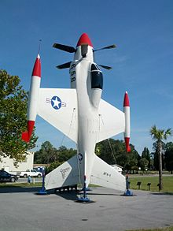

Figure 2. 5 Lockheed XFV

Rotor fixed wing aircraft combines the flying mechanism of a copter with a conventional aircraft. The number of rotors used depends on the mission flight. Figure 2.6 displays the example of a quad-rotor fixed-wing aircraft.

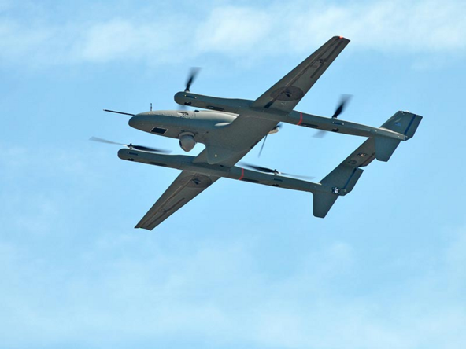

Figure 2. 6 HQ-60 Hybrid Quadrotor UAV

This type of VTOL UAV is designed to maximize the flying qualities of an aircraft (Gunarathna and Munasinghe, 2018). This is because a rotor fixed-wing UAV is a combination of a conventional fixed-wing UAV and a rotorcraft UAV in which it uses the advantage of having long endurance from a traditional fixed-wing and the high manoeuvrability and the capability to vertically take-off and landing of a rotorcraft UAV (Abd Rahman et. al, 2018). Therefore, in short, a rotor fixed-wing UAV has two lift generators which are the blades of its rotor and the fixed wing itself.

The common configuration of the quad-rotor is the ‘X’ configuration as shown in Figure 2.7 below in which rotor A and C will rotate in the clockwise direction while rotor B and D will rotate in the counter clockwise direction. The reason why the pairs that rotate in the same direction are AC and BD is to stop the body of the aircraft from experiencing moment to counter the rotation of the propeller blades. The speed of the rotation of each of the propeller is the actuator to the attitude of the quadrotor (Abd Rahman et. al, 2018).



Figure 2. 7 Quadcopter ‘X’ configuration

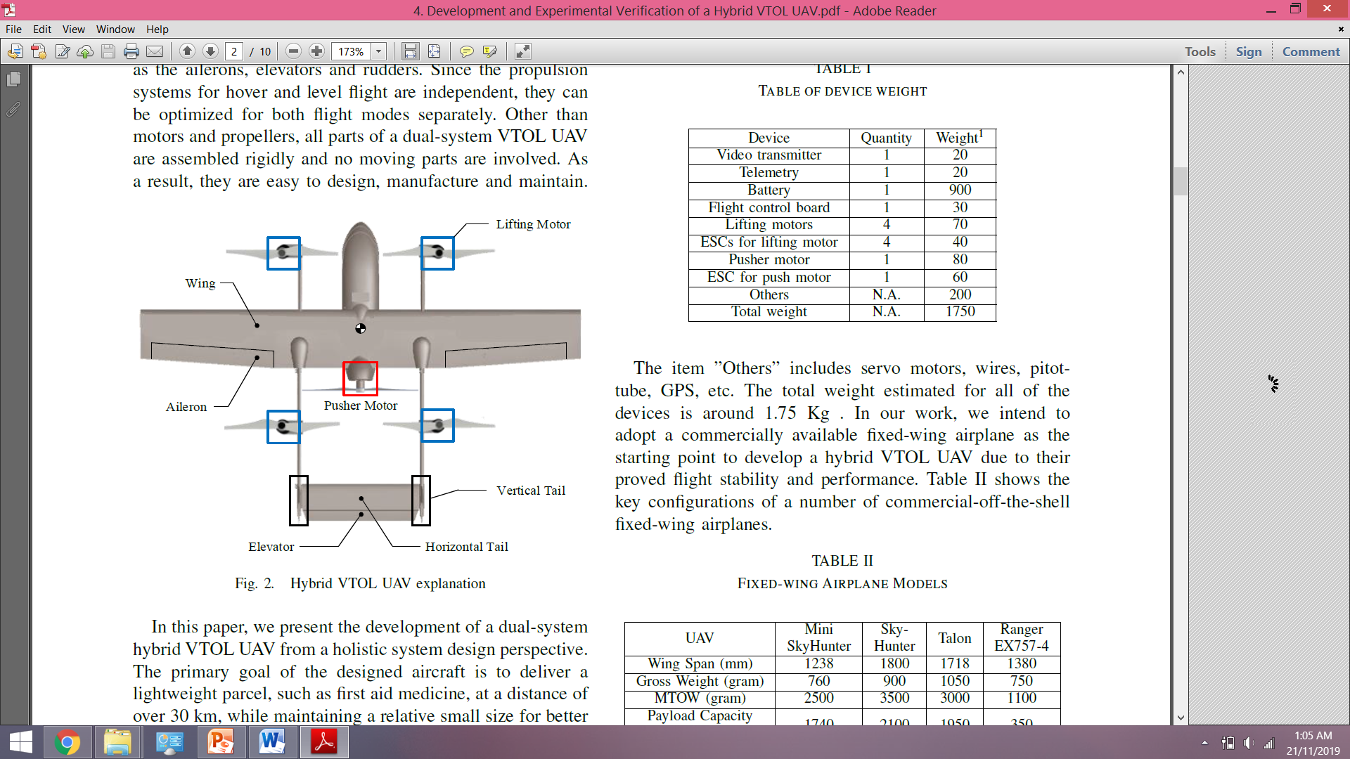

Figure 2. 8 Quadcopter ‘X’ configuration on conventional fixed-wing UAV

There are basically three flying modes for this type of aircraft which are the vertical take-off mode, transition mode which includes hovering and cruising, and lastly the vertical landing mode (Abd Rahman et al., 2018). The rotation of the propeller of the rotor will create thrust for all the flying modes mentioned above. Since thrust is a force therefore thrust is measured in Newton unit and we know that 1N is equivalent to 1kgms-2. Here we can say that thrust is the amount of force required to accelerate 1 kilogram of mass at 1 meter per second squared. The speed of rotation of the propeller blades play very important role in producing thrust because one of the parameter that controls amount of force produced is the angular velocity.



W

L

L

L

L

Figure 2. 9 Lift force and weight acting on the body of the aircraft

During taking off, the four rotors will rotate and the blades will push air downwards. By recalling back Newton’s Third Law, when there is an action force acting on a body, there must also be a reaction force with the same magnitude that act as opposite to the action force (Resnick & Halliday, 1977). Due to this law, therefore the amount of air being pushed downwards or the thrust produced will simultaneously create an upward force called lift force. However, in order for the aircraft to fly, the lift produced must be greater than the weight of the aircraft. As mentioned previously, the amount of thrust force produced relies on the speed of the rotation of propeller blades. Therefore, the large amount of lift wanted, the faster the speed of rotation of the propeller blades. Meanwhile during landing, as opposed to the taking-off mode, the lift produced must be lesser than the weight. Hence, the propeller needs to rotate at a slower speed in order to land vertically. Figure 2.2 shows the details of the lift force and weight acting on the aircraft.

Hovering is the state of when an aircraft is being able to remain in the air. As according to the equilibrium of forces, in order to produce zero net force, the lift produced must be equal to the weight of the aircraft. However, it is important for aircraft to stabilize itself first before changing from hovering mode to cruising mode. This is because even though the aircraft stays afloat during hovering, there is still perturbation coming especially from the wind. Unlike helicopter, a quad-rotor’s pitch of the blades does not change throughout its flying mode but instead, it changes the rotation speed of the rotors in order to stabilize its body. After making sure the aircraft is stable enough, only then the pusher will produce enough thrust to push the aircraft forward and then the four vertical rotors will slowly stop rotating, allowing for cruising mode to take place.

If the aircraft wants to yaw to the right, by referring to Figure 2.1, the rotor that rotates in clockwise direction which is rotor A and C need to rotate slower than the B and D rotor. This will result in zero angular momentum so the aircraft will tend to move in the clockwise direction in order to cancel the angular momentum produced from the rotation of the counter-clockwise rotor. If the case requires the aircraft to roll a bit to the right then the rotor A and D are the ones that need to have slower speed rotation than rotor B and D. For quad-rotor, rolling to the right means to fly the VTOL aircraft sideways to the right while pitching means we fly the aircraft forward or backward. Note that the configuration of the quad-rotor is symmetry therefore the movement for rolling and pitching have basically the same concept. If we want to roll to the right then we need to increase the velocity of the pair of rotors at the right hand side and the same concept applied to pitching. If we want to pitch the aircraft forward then speed rotation of the rotor A and B needs to be lowered.

Meanwhile at the cruising mode, the quad-rotor fixed-wing acts like a conventional aircraft since the lift produced at this mode solely comes from the wing. This means that pusher is the only source of power and wing is the lift generator for forward flight of a quad-rotor fixed-wing aircraft. The control surfaces that control the stability of the aircraft are also the same as conventional aircraft which are the ailerons, rudder and elevator.

## Basic Electronic Components in a UAV

Among the basic electronic components that are normally being used in a quad-rotor fixed-wing UAV are battery, motor, propeller, electronic speed controller or ESC, receiver and transmitter and servo. These electronic components are the basic components to get the UAV moving. However, if we intend to collect flight data for the flight path or location of the UAV, therefore we must put three additional components which are the GPS module, telemetry and the Arduino.

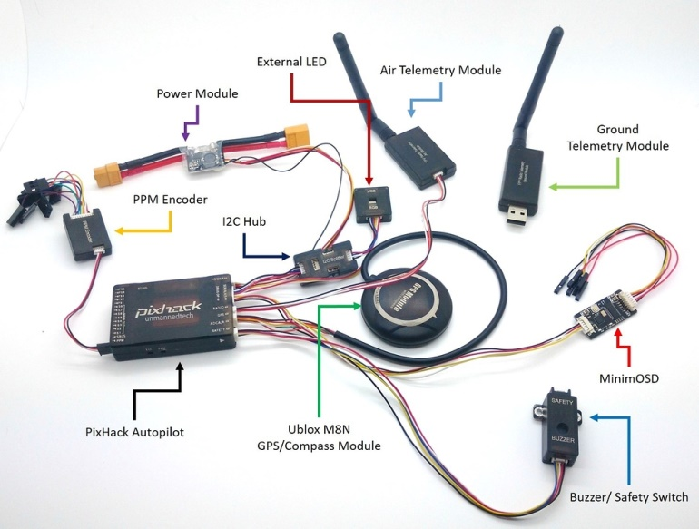

Figure 2. 10 Arrangement of the electronic components

### Battery

Battery in general is a container that is made up of one or more cells. These cells are functioning as the converter of chemical energy into electrical energy. That is why battery is one of the sources of power. As mentioned in previous subtopic, almost all lightweight UAV uses electrical energy as the source of power for its propulsion system. Battery can be categorized into two categories which are the single use category and the rechargeable category. The rechargeable one is obviously being selected more often due to its advantage of being more energy efficient and produces less waste than the single use.

The most frequently used rechargeable battery in aviation is the Lithium-Polymer battery as shown in Figure 2.11. Instead of using liquid electrolyte like the common battery, a Lithium-Polymer battery or better known as Li-Po battery uses polymer electrolyte which is formed from the gel or semi-solid polymers that have high conductivity. A Li-Po battery is very suitable for the usage of devices that have weight as one of the critical elements (Bruno et. al, 2013). This is because the specific energy being provided by a Li-Po battery is higher than any other lithium battery.

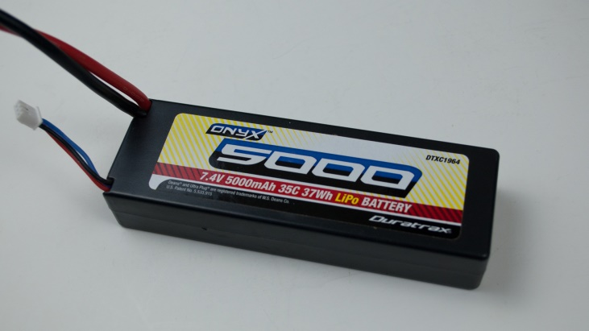

Figure 2. 11 Li-Po battery

The next type of rechargeable battery that is popular in aviation is the Lithium-Ion battery. Commonly, the negative electrode of a Lithium-Ion battery is made up of graphite while its positive electrode is made up of lithium compound. Furthermore, just like any other batteries, the ion or in this case the lithium ion moves through the means of electrolyte from negative electrode to positive electrode. However, as the battery is being charged, the lithium ions move positive electrode back to the negative electrode again. The advantage of this battery is that it has a low self-discharge despite of having high density of energy.

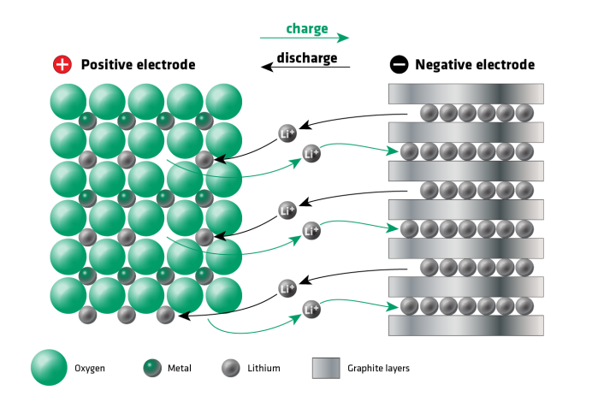

Figure 2. 12 Lithium-Ion battery

### Motor

A motor is used to convert the electrical energy obtained from source of power previously into mechanical power or motion. There is variety of choices on type of motor that can be used in different applications but there are only two that are the most common. The first one is the brushed motor while the other one is the brushless motor.

Normally, a brushed motor is made up of a rotor and a stator. The rotor is equipped with electromagnets while the stator is equipped with either wound or permanent magnet as shown in Figure 2.13 below. A brushed motor starts working the moment its coil is being powered. A magnetic field around the armature of the brushed motor is created at this moment. At the beginning, the armature’s left hand side will be pulled towards the right magnet while simultaneously being pushed away by the left magnet. This condition has caused rotation to occur.

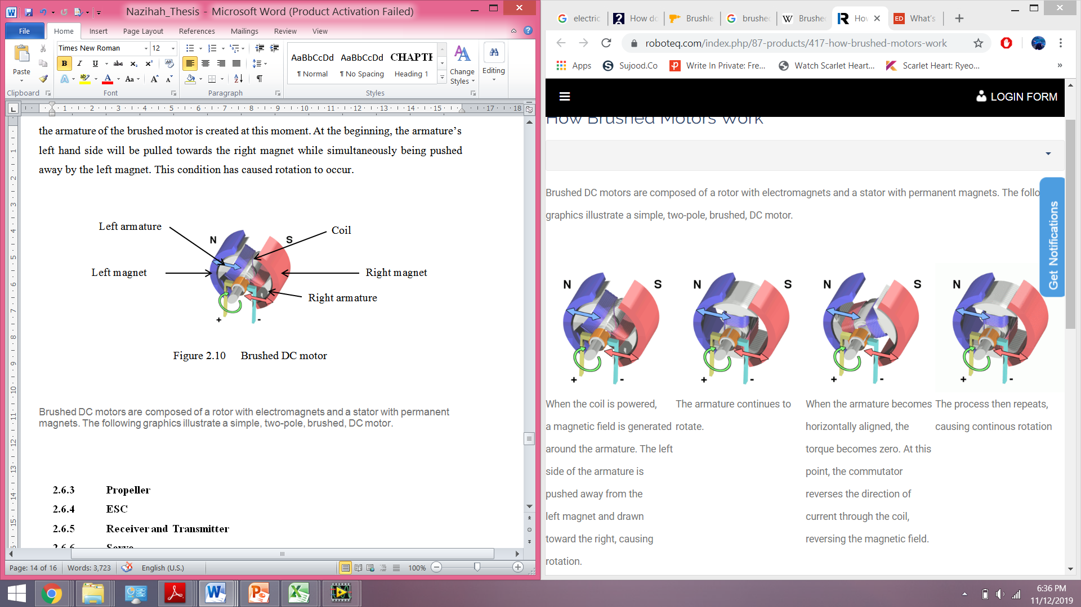

Figure 2. 13 Brushed DC motor

Brushed motor is less expensive as compared to brushless motor due to its simpler configuration and design. Brushed motor also have higher value of torque and ratio of inertia. However, the performance of a brushed motor can be reduced over time due to the brush being worn out. Besides, the brushes of this type of motor also need a regular maintenance since it is very sensitive to dust.

The second type, which is the brushless motor is a bit different from a brushed motor since the brushes are being cut off. To cater this change, the permanent magnet is changed to the rotor while the stator holds the electromagnets.

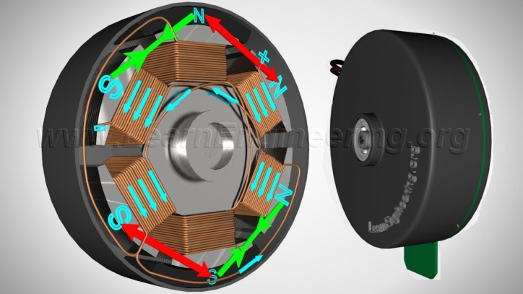

Figure 2. 14 Brushless DC motor

Unlike brushed motor, a brushless motor has more advantages than the disadvantages. That is why nowadays brushless motor is being used more often than a brushed motor. The first advantage of a brushless motor is that the elimination of brushes that require regular maintenance saves a lot of time and operating cost. In addition to that, the rotating motor does not have any problem to cool down within a short period of time since the electromagnet is now positioned with the stator.

### Propeller

Since thrust is needed for the aircraft to lift off from ground and to push or pull aircraft, therefore the function of propeller is to convert power produced by engine into thrust. By observing the propeller, we can also see that the root of the propeller blades are a bit twisted. This twist acts as the angle of attack for the propeller and functions the same as angle of attack for conventional fixed-wing aircraft. Since the propeller tip moves faster than the root, that is why the twist is located at the root of the propeller blades.

The sizing of a propeller normally will look exactly as shown below. As an example, the 12 at the front indicates the total length of the propeller form one end to another end. While the number 6 at the end of the sizing is referring to the pitch angle of the propeller. Pitch angle of the propeller in this case means that for one complete rotation, the aircraft will move 6 inch forward.



Figure 2. 15 Propeller

### ESC

The function of an electronic speed control or better known as ESC (Figure 2.16) is to control the speed of a motor or specifically an electric motor. ESC is an electronic circuit. Other than that, an ESC also acts as a dynamic brake.

Commonly used ESC that is used with a radio-controlled airplane contains safety measures. It controls and regulates amount of power coming from the power source. As an instance, if the power obtained from battery is too little then ESC will control the power supplied to motor by decreasing it. Even though the ESC decrease the power supplied to motor, ESC still lets the control surfaces of the airplane to function so that the airplane can glide for safety.

Typically, an ESC consists of three sets of wires. One is for the power source for the radio-controlled airplane, another one is for the receiver’s throttle and lastly is to power the motor.

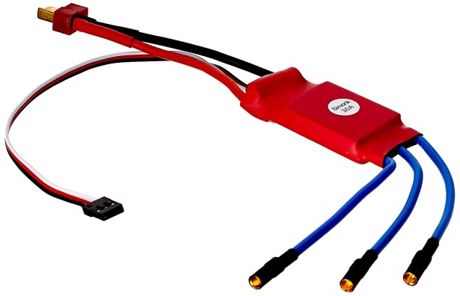

Figure 2. 16 Electronic Speed Controller

### Receiver and Transmitter

Both receiver and transmitter are categorized under the category of control gear or control system. Back in the old days, there are several things included in control gear which are the receiver, transmitter, servo and battery charger. However, as for now, people will only buy the receiver and transmitter since they want to modify their own servos that suit their airplane. While transmitter functions as the signal emitter, a receiver functions as the signal receiver.

The transmitter is also commonly known as the radio is actually the most important device used for controlling airplane. There are many different configurations of transmitter that can be chose according to the pilot’s preference. The number of channels that are normally used in a transmitter is 4. These four channels are for rudder, ailerons, elevator and throttle. Besides, there are also 1 channel, 2 channels and also 3 channels. Just like the 4 channels, a 1 channel transmitter can only control one function, either the control surface or the on or off of the electric motor.

Just like the television or radio collects signal from the broadcasting station, a receiver collects signal information from transmitter when the transmitter is being used to control airplane. After receiver collects the appropriate amount of signal, it is being passed to the other electric components in the airplane such as servos, ESC and motor for them to respond according to the desired input.

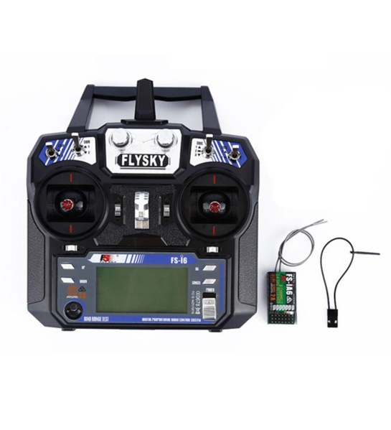

Figure 2. 17 Transmitter and Receiver

### Servo

Servo, or also known as a servo motor (Figure 2.18), is a turning actuator that permits control to be made precisely for angular position, acceleration and velocity. It is a device that acts as assistant to the movement of control surfaces. It is hinged and is small in size. Servo motor does not apply the full or true form of the servomechanisms since servo motor does not use any feedback to assist the movement of the control surfaces. Therefore, by combining both servo motor and regular motor, the system now is capable for position feedback. Servo motor functions by moving in the direction opposite to the desired or input movement.

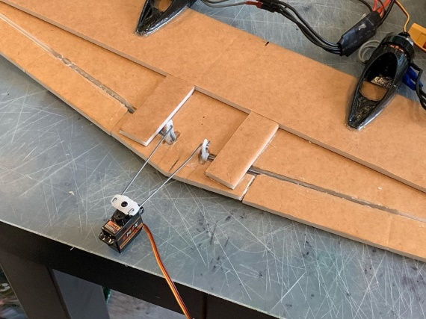

Figure 2. 18 Servo connected at the control surface of RC plane

### GPS Module

Global Positioning System or GPS module is a GPS device that requires the connection to a computer for it to works. The GPS module normally comes alone when being purchased therefore the user needs to install a GPS navigation software by their own. A GPS module works by receiving information from the GPS satellites. This device then will calculate the current geographical location. The GPS module then will send the data to the GPS navigation software so that the location will be displayed on the computer screen.

A GPS module measures the location of the RC plane by calculating how long a signal takes to travel from a satellite. Other than that, a GPS module is also capable of giving the estimation of the altitude of the RC aircraft. The main feature used by the GPS module is that the aircraft can be flew autonomously to way-points, so that the plane can fly on its own from takeoff to landing.

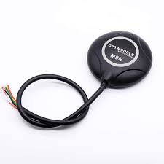

Figure 2. 19 High Precision GPS Module

### Telemetry

Telemetry is used to collect the flight data from remote sensors. The usage of telemetry allows the pilots to keep checking the status of the moving airplane from ground. Among the data that the telemetry can store are the current location in terms of GPS coordinates, battery voltage, and current from motor. All this data can also be downloaded to the flight data recorders. Adding telemetry to the RC plane is very useful to analyze the RC aircraft later, but is not compulsory.

The telemetry modules are the actual radio devices that transmit and receive the data. One will be placed onboard together with the plane and one on the ground plugged onto the ground station device or specifically, a laptop. The most important thing when using telemetry modules is that it needs to be paired together with autopilot for them to communicate.

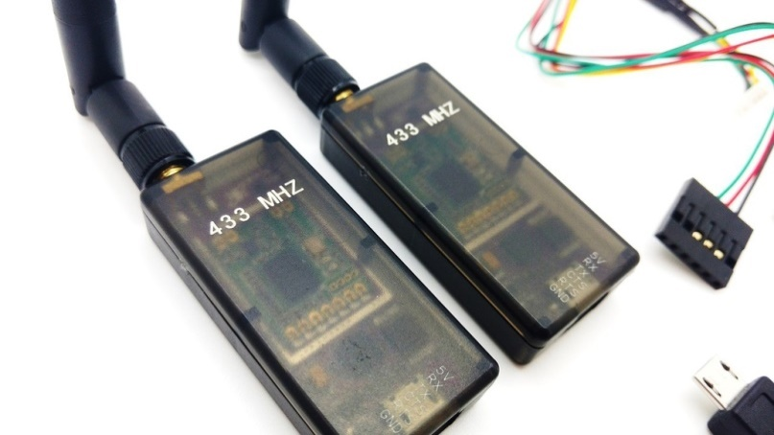

Figure 2. 20 Telemetry

## Control System

For a simplification, control system can be defined as a system that controls other systems. Normally, a block diagram as shown in Figure 2.9 is used to represent one whole system for a better visualization and understanding. Each block represents either an element or process and each block is linked by the output and input signal. There are two strategies in solving problems related to control system which are the open loop control system or better known as feedforward system and also the closed-loop control system or a feedback system (Jamaluddin et. al, 2015).

An open loop control system is a system that is not capable to correct its output automatically with varied input values (Nagrath, 1975). Therefore, for this type of control system, the output will remain unchanged together with the unchanged value of input. But this is only applicable if the external conditions also stay unchanged. Figure 2.21 displays a sample of open loop block diagram.

Process

Input Variable

Output Variable

y(t)

u(t)

Figure 2. 21 Simple block diagram for an open loop system

Meanwhile a closed-loop control system is a system that is capable to correct its output automatically, as opposed to the open-loop control system. This is done by adding a controller into the system.

Figure 2. 22 Simple block diagram for a closed-loop system

Process

Input Variable

Output Variable

y(t)

u(t)

Controller

A closed-loop control system will have a controller that controls the output of the system to be derived from a certain function of the input. As cited from Jamaluddin, Yaacob and Ahmad (2015), a simple dynamic system as illustrated in Figure 2.9 requires a suitable control signal or controller value in order to ensure the desired output can be achieved. This control signal can be the proportional gain, integral gain or derivative gain depending on the type of output is required. The gain can also be combined to improve the output produced at the end of the process. The gain then formed the type of controller used for the system.

There are various types of controller which are the Proportional Controller, Proportional-Integral Controller, Proportional-Derivative Controller and Proportional-Integral-Derivative Controller. However, basically all of these controllers are designed so that the particular control system is able to ensure that the actual output is similar to the output that is being targeted to be achieved.

### Proportional Controller

Since a proportional controller or P controller is the simplest form of controller as compared to the others, therefore the usage of P controller normally only involves the first order process (Bajpai, 2018). A proportional gain basically amplifies the output respond as according to the error exists in the control system.

G(s)

Input Variable

Output Variable

y(t)

u(t)

KP

Figure 2. 23 Simple block diagram with KP gain

### Proportional-Integral Controller

Secondly, Proportional-Integral controller or P-I controller have both P and I gain. The P gain works exactly like in P controller but the integral gain functions as an eliminator of the residual error from P gain. However, as the error is being diminished, the integral term will keep on increasing.

G(s)

Input Variable

Output Variable

y(t)

u(t)

$$\frac{K_{P}(s+K_{i})}{s}$$

Figure 2. 24 Simple block diagram with both KP and Ki gain

### Proportional-Integral-Derivative Controller

A Proportional-Integral-Derivative or PID Controller is the most optimum controller since this type of controller has all gains. As mentioned earlier in PI controller, the integral term will keep on increasing. Therefore, a Derivative gain is added so that it eradicates the overshoot caused by Integral term. Shown below is the PID controller block diagram.

KD

KI

Input Variable

Output Variable

y(t)

u(t)

KP

Figure 2. 25 PID Controller

# METHODOLOGY

## Introduction

The research on quad-rotor fixed-wing UAV has been carried out to fulfill the objective of determining the fatigue life of its wing and the highest energy consumption. This chapter will elaborate in detail all the steps involved and the flow of the process in acquiring the data to validation of experimental setup.

## Flow Chart

Flow chart below shows the methodology used in this research project in order to fulfill all the objectives.

Figure 3.1 Flow Chart

Analytical calculation

Propulsion System

Structural

Control System

Propose Experiment

MATLAB Programming

Result

No

Yes

Set-Up Experiment

Prepare for Flight Test

Run Experiment

Flight Test

Result

No

No

Yes

Data Collection & Validation

Discussion

Draw Conclusion

UGP 1

UGP 2

Figure 3.1 Flow Chart

## Reference UAV

As stated in chapter 1 earlier, the hybrid UAV used for this project is a quad-rotor fixed-wing UAV.

### Dimension

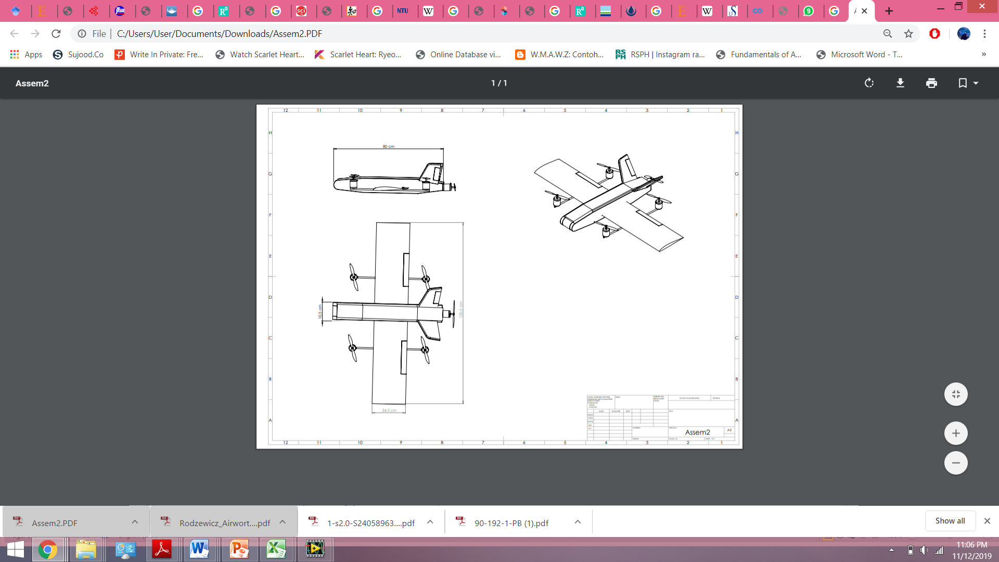

Figure 3. Quad-rotor Fixed-wing UAV Solidwork Model

### Mass and Balance Analysis

The centre of gravity for an aircraft can be defined as one point that would make the aircraft stays balanced (Federal Aviation Administration, 2007). This point also plays a very important role in determining the stability of an aircraft. The location of the CG for three major components in aircraft (fuselage, wings and engines) are normally can be determined from theoretical concepts. However, we need to decide by ourselves by doing the estimation method to determine the CG of the smaller components such as the battery and motor. Table 3.1 shown below is the tabulated data of the estimated mass and location for each component.

Table 3. UAV Weight

|  |  |  |  |  |  |  |  |  |
| --- | --- | --- | --- | --- | --- | --- | --- | --- |
| No. | Components/Parts | Unit | Weight per unit (kg) | Total Weight (kg) | Position | | Mx (kg.m) | Mz (kg.m) |
| X (m) | Z (m) |
| 1 | Motor and propeller |  |  |  |  |  |  |  |
|  | Front VTOL | 2 | 0.183 | 0.366 | 22.8 | 2.5 | 8.345 | 0.92 |
|  | Rear VTOL | 2 | 0.183 | 0.366 | 57.2 | 2.5 | 20.935 | 0.92 |
|  | Pusher | 1 | 0.183 | 0.183 | 80 | 0 | 14.640 | 0.00 |
| 2 | Metal bar | 2 | 0.057 | 0.114 | 40 | 0 | 4.560 | 0.00 |
| 3 | Servo | 2 | 0.014 | 0.028 | 52 | 0 | 1.456 | 0.00 |
| 4 | Battery | 1 | 0.452 | 0.452 | 40 | 0 | 18.080 | 0.00 |
| 5 | Fuselage | 1 | 0.800 | 0.800 | 40 | 0 | 32.000 | 0.00 |
| 6 | Wing | 2 | 0.500 | 1.000 | 32.8 | 0.72 | 32.800 | 0.72 |
| 7 | V-Tail | 1 | 0.300 | 0.300 | 80 | 5 | 24.000 | 1.50 |
| 8 | Arduino | 1 | 0.046 | 0.046 | 38 | 0 | 1.748 | 0.00 |
| 9 | ESC | 1 | 0.097 | 0.097 | 28 | 0 | 2.716 | 0.00 |
| 10 | Telemetry | 1 | 0.021 | 0.021 | 40 | 0 | 0.840 | 0.00 |
| 11 | GPS Module | 1 | 0.033 | 0.033 | 40 | 3.024 | 1.320 | 0.10 |
| 12 | Receiver | 1 | 0.034 | 0.034 | 50 | 0 | 1.700 | 0.00 |
| TOTAL WEIGHT | | | | 3.84 | TOTAL MOMENT | | 165.140 | 4.15 |

### CG Estimation

$X_{1}=\frac{Total moment, \sum{M_{x}} \left(kgm\right)}{Total weight, \sum{W} \left(kg\right)}$ (3. 1)

$$=\frac{165.14 kgm}{3.84 kg}$$

$$=43.005 m$$

$Z_{1}=\frac{Total moment, \sum{M_{z}} \left(kgm\right)}{Total weight, \sum{W} \left(kg\right)}$ (3. 2)

$$=\frac{4.15 kgm}{3.84 kg}$$

$$=1.081 m$$

## Structural Analaysis

### Wing Specification

The structure of the wings used in this project is made of foam. However for both main spar and aft spar is made of hollow box steel. The important parameters for the wing is listed in Table 3.2 below.

Table 3. Wing Specification

|  |  |
| --- | --- |
| Type of Wing | Straight Wing |
| Airfoil Type | E205 |
| Wingspan | 1.2 m |
| Semi-span | 0.6 m |
| Wing Area | 0.294 m2 |
| Aspect Ratio | 4.9879 |
| Chord | 0.245 m |

### Shear Force and Bending Moment Diagram

The free body diagram of the problems is illustrated in Figure 3.4 and its respective shear force and bending moment diagram is determined. The importance of shear force and bending moment diagram is so that we are able to determine the critical areas of the structure.

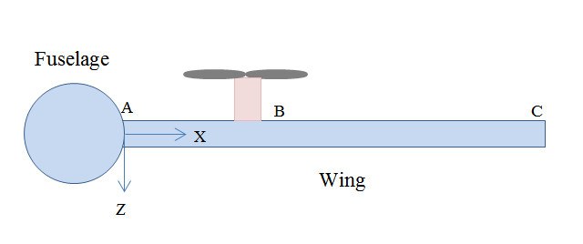

Figure 3. 2-Dimensional Wing-Fuselage Joint

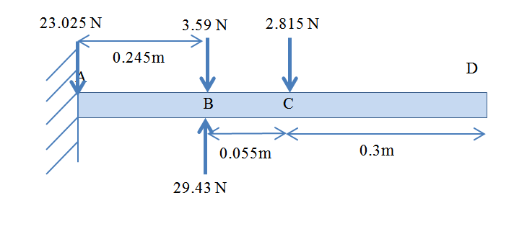

Figure 3. Free body diagram

### Wing Deflection Set-up

For the analysis on body structure, an experiment is then conducted with the objective to find the effect of VTOL motors on the deflection of the wings. The experiment requires 100g sandbags, dial gauge with stand, stationary rig, bracket, screw and washer, E205 airfoil wing and hollow box steel. The procedure for this experiment is divided into two parts which are the preparation of E205 airfoil wing and the experimental set-up to find the wing deflections.

#### Preparation of the Airfoil Wing

This experiment is carried out without disturbing the real wing that has been attached to the reference UAV. Therefore a new wing model is created in order to run the experiment. The procedure to prepare the wing with E205 airfoil starts with creating a CAD drawing of the airfoil. Then, export the drawing to the CNC hot wire cutting machine. Put foam at the platform and let the machine run. Lastly, pass a hollow box steel inside the airfoil to act as main and aft spar of the wings. Only half wing is used for this experiment to cut the cost and time.

#### Set-up for Wing Deflection Test

In order to run an experiment, the apparatus and materials must be arranged first accordingly. This is to minimize the error during data collection later. The first step is to attach the wing upside down to bracket. This is done to simulate the lift force that acts upwards during flying. Secondly, fasten the bracket to the stationary rig by using screw and washer as shown in Figure 3.5 and Figure 3.6.

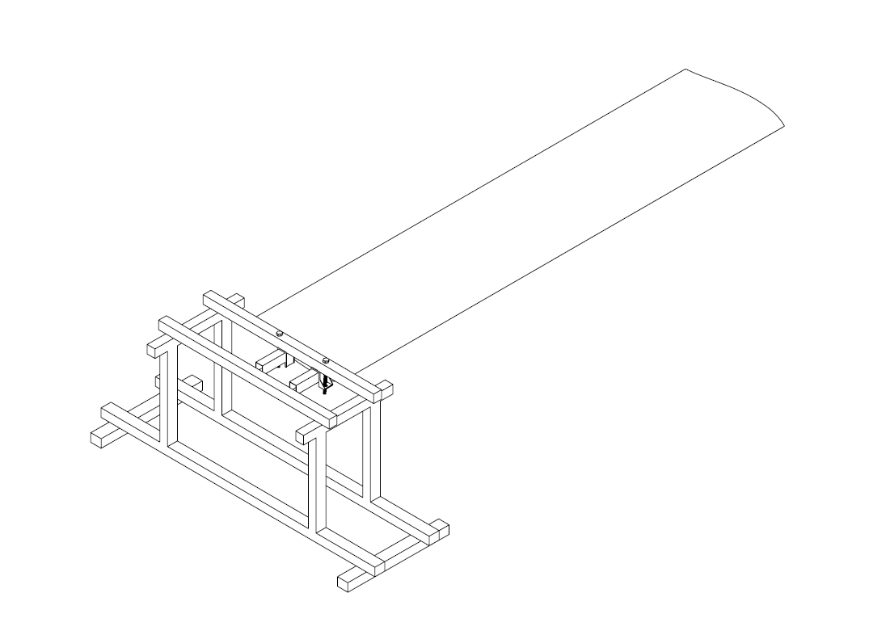

Figure 3. Stationary rig holding the wing

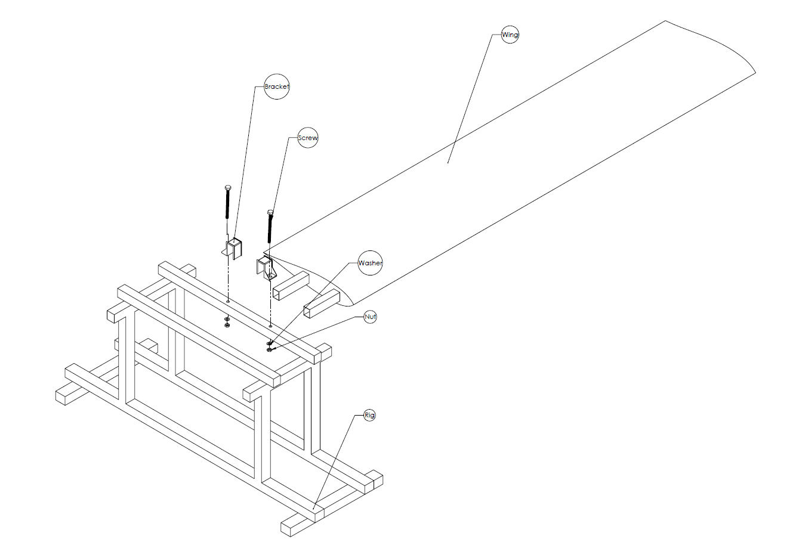

Figure 3. The detailed drawing for experimental set-up

After that, place dial gauges at four different locations which are the root, location of motor, middle and tip of the wing. For better accuracy, a digital dial gauge is suggested to be used. Place weight on the location of the VTOL motors. In this case, a sandbag is used to simulate the weight. Collect and tabulate data as shown in Table 3.3. During taking off, the thrust produced by the motor is the lift force and this equation is used. In which velocity during taking off is assumed to be in the range of 0 m/s to 3 m/s. the respective thrust and weight value is also calculated by using equation 3.3.

$T_{TO}=\frac{\left(W_{TO}+\frac{1}{2}ρV_{TO}^{2}S_{ref}C_{D,O,axial}\right)}{ŋ_{motor}N}$ (3. 3)

Table 3. Deflection Table

|  |  |  |  |  |  |  |  |
| --- | --- | --- | --- | --- | --- | --- | --- |
| **No** | **Velocity (m/s)** | **Force (N)** | **Weight (kg)** | **Deflection at wing** | | | |
| Root | Motor | Middle | Tip |
| **1.** | 0 | 0 | 0 |  |  |  |  |
| **2.** | 0.5 | 1.458 | 0.15 |  |  |  |  |
| **3.** | 1.0 | 5.832 | 0.60 |  |  |  |  |
| **4.** | 1.5 | 13.121 | 1.35 |  |  |  |  |
| **5.** | 2 | 23.328 | 2.40 |  |  |  |  |
| **6.** | 2.5 | 36.449 | 3.70 |  |  |  |  |
| **7.** | 3.0 | 52.488 | 5.35 |  |  |  |  |

Next, plot graph of velocity against load and deflection of wing against total load for all four positions of the dial gauges.

## Analysis on Propulsion System

### Thrust and Power Required Calculation for Fixed Wing Mode

For fixed wing mode, only the cruising state is involved. In order to ensure that the quad-rotor fixed-wing UAV is able to fly at a specific velocity, the thrust produced by the propulsion system must equal to the drag. This is proved by the equation shown below (3.4). By substituting equation (3.5) into (3.4), we obtain equation (3.6).

$T_{R}=D=\frac{1}{2}ρv^{2}SC_{D}$ (3. 4)

$C_{D}=C_{D,0}+\frac{C_{L}^{2}}{πEAR}$ (3. 5)

$T_{R}=D=\frac{1}{2}ρv^{2}SC_{D/0}+\frac{1}{2}ρv^{2}S\frac{C_{L}^{2}}{πeAR}$ (3. 6)

We also know that at steady and level flight, the lift force is equal to the weight of the UAV therefore we obtain equation (3.7).

$C_{L}=\frac{2L}{ρv^{2}S}=\frac{2W}{ρv^{2}S}$ (3. 7)

There it can be seen that there is a $\frac{W}{S}$ inside the equation of CL in which W is the total weight of the aircraft and S is the area of the wing. In other word, wing loading affects the value of CL.

The dimensionless parameter of CD/0, or coefficient of drag at zero lift can be easily determined from the website Airfoil Tools. But first, the Reynolds Number needs to be calculated. The formula for Reynolds Number is as shown below (3.8).

$Re=\frac{ρvc}{μ}$ (3. 8)

After obtaining the value of Reynold Number, the angle of attack at CL/0 is determined from graph CL against $α$ at respective value of Reynolds Number.

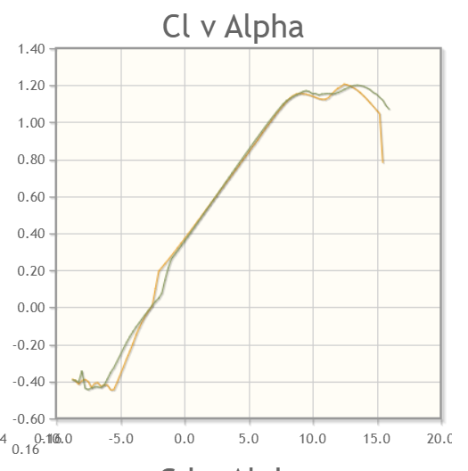

Figure 3. Graph of CL against $α$

After that, refer to the graph CD against $α$ shown below. By using the value of $α$ obtained previously, the corresponding value of CD or CD/0 is obtained.

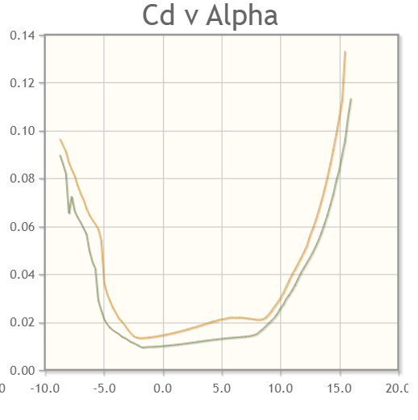

Figure 3. Graph of CD against $α$

As for fuselage, we are using the DATCOM method to determine the respective values of coefficient needed by using equation (3.9) while motor’s coefficient will be determined from wind tunnel testing.

$C_{D,0}=C_{F}\left[1+\left(\frac{60}{{\left(\frac{l_{B}}{d}\right)}^{3}}\right)+0.0025\left(\frac{l_{B}}{d}\right)\right]\frac{S_{S}}{S_{B}}+C_{D/b}$ (3. 9)

In addition to all those equations, power required equation is the same as equation of thrust required for fixed wing mode. Therefore, equation (3.10) gives the equation of power required.

$P_{R}=T_{R}×V=D=\frac{1}{2}ρv^{2}SC_{D/0}+\frac{1}{2}ρv^{2}S\frac{C_{L}^{2}}{πeAR}$ (3. 10)

### Thrust and Power Required Calculation for Fixed Wing Mode

Unlike fixed-wing mode, the quad-rotor mode needs to take into account the three crucial conditions which are the take-off, hover and landing. As for maximum thrust, the equation for its thrust and power required are as displayed below (Wang et. al, 2015).

$T_{max}=K_{T}W_{TO}$ (3. 11)

Where KT represents thrust to weight ratio. The suggested value of thrust to weight ratio for a hybrid VTOL is 1.15 or more times higher than the maximum take-off weight (Wang et. al, 2015). Therefore, this study proposed 1.2 as the value of KT.

As for the take-off flying condition, the thrust and power required for each propeller can be calculated as shown below (equation 3.12 and 3.13 respectively).

$T_{TO}=\frac{\left(W_{TO}+\frac{1}{2}ρV_{TO}^{2}S_{ref}C_{D,O,axial}\right)}{ŋ_{motor}N}$ (3. 12)

$P_{TO}=\frac{T_{TO}V_{T0}}{2(ŋ_{propMR})}\left[2+\sqrt{1+\left(\frac{2T_{TO}}{ρA_{prop}V_{TO}^{2}}\right)}\right]$ (3. 13)

The CD,0,axial in the thrust required equation for take-off refers to the coefficient of drag in axial climb. This value is assumed to be 1.9 for Reynolds Number between 104~105.

The UAV needs to hover in order to change the flying mode from VTOL to the conventional fixed-wing. The power required for the UAV to hover and its induced velocity is as displayed below (equation 3.14 and 3.15).

$P_{H}=\frac{{\left(\frac{W_{TO}}{ŋ_{motor}×N}\right)}^{3/2}}{ŋ_{propMR}\sqrt{2ρ×A_{prop}}}$ (3. 14)

$V_{H}=\sqrt{\frac{\left(\frac{W_{TO}}{ŋ_{motor}×N}\right)}{2ρ×A_{prop}}}$ (3. 15)

The velocity to land or VLD is twice less than VH therefore the descend induced velocity or Vi can be calculated from the equation 3.16 and 3.17.

$V_{i}=V_{H}(1.2-1.125x-1.372x^{2}-1.718x^{3}-0.655x^{4})$ (3. 16)

$x=-\frac{V_{LD}}{V_{H}}$ (3. 17)

So now we obtain the thrust and power required equation for landing by using multi-rotor mode (equation 3.18 and 3.19).

$T_{LD}=\frac{\left(W_{TO}-\frac{1}{2}ρV_{TO}^{2}S_{ref}C_{D,O,axial}\right)}{ŋ_{motor}N}$ (3. 18)

$P_{TO}=\left(\frac{T_{LD}}{ŋ_{propMR}}\right)\left(V_{i}-V_{LD}\right)$ (3. 19)

### Subsystem Efficiency

The subsystem efficiency cited from Jamaludin (2018) is tabulated into table shown below.

Table 3. 4 Subsystem Efficiency

|  |  |  |
| --- | --- | --- |
| Equipment | Symbol | Value |
| Fixed-wing Propeller | $$ŋ_{propFW}$$ | 0.7 |
| Multi-rotor Propeller | $$ŋ_{propMR}$$ | 0.8 |
| Motor | $$ŋ_{motor}$$ | 0.85 |
| ESC | $$ŋ_{ESC}$$ | 0.65 |
| Fixed-wing total | | 0.48 |
| Multi-rotor total | | 0.44 |

### Flight Test

The flight test for this analysis will be done in 5 modes which are idle mode, take-off mode, hovering mode, cruising mode and landing mode. Then the experiment is repeated with different altitude before the data is being retrieved from Mission Planner software.

Firstly, for iddle mode, switch on the power source and leave the UAV without turning on the motor for 3 minutes. Even though the propeller does not rotate in this mode, the change of signal between transmitter and receiver, and other internal processing still requires power. The current consumption during the 30 seconds is auto recorded by the watt meter.

Secondly, the take-off mode. The UAV is set to take off until it reaches 2m height from the ground. The current consumption of the 4 VTOL motors is now being recorded by the watt meter.

As for the hovering mode, the UAV is made to hover at 1m altitude for a period of 30 seconds so that the wattmeter can record the reading of the current consumption during the allocated time.

After that, during the horizontal flying mode or cruising, turn off the VTOL motors and let only the tractor motor to run. Fly the UAV at 2m altitude for 30 seconds. Please ensure to keep the velocity to stay constant as much as possible.

Next, repeat all previous steps but with different altitude which are as tabulated in table below before retrieve all the current consumption data that has been collected from Mission Planner software. Equation 3.20 is used to calculate the power consumption.

$P=V×I$ (3. 20)

Table 3. 5 Result for average current consumption

|  |  |  |  |  |  |
| --- | --- | --- | --- | --- | --- |
| Altitude (m) | Flying mode | | | | |
| Idle | VTOL (Take-off) | Hovering | Cruising | VTOL (Landing) |
| Average Current Consumption | | | | |
| Ground |  | N/A | N/A | N/A | N/A |
| 1 | N/A |  |  |  |  |
| 2 | N/A |  |  |  |  |
| 3 | N/A |  |  |  |  |
| 4 | N/A |  |  |  |  |
| 5 | N/A |  |  |  |  |
| 6 | N/A |  |  |  |  |
| 7 | N/A |  |  |  |  |

## Analysis on Control System

For the control system, the flight test done to find the most suitable value of P, I and D gain is through the tuning test. Since the reference UAV is a hybrid VTOL therefore there are two different types of tuning which are for fixed-wing and also for multi-rotor. By doing tuning test, we will get the most suitable value for P, I and D gain to stabilize the aircraft.

### Preparing for Tuning Test

The first step is to set the value of battery voltage compensation maximum voltage (MOT_BAT_VOLT_MAX) by using the recommended equation (3.21).

$4.4×no of cells in battery$ (3. 21)

Secondly, set the value of battery voltage compensation minimum voltage (MOT_BAT_VOLT_MIN) by using the recommended equation (3.22).

$3.5×no of cells in battery$ (3. 22)

Then, set the thrust curve expo (MOT_THST-EXPO) to 0.55 for 5 inch diameter propeller, 0.65 for 10 inch diameter propeller and 0.75 for 20 inch diameter propeller. After that, proceed to set the gyro filter cutoff frequency (INS_GYRO_FILTER) to 80Hz for 5 inch diameter propeller, 40Hz for 10 inch diameter propeller, 20Hz for 20 inch diameter propeller. Next, set both pitch and roll axis rate controller input frequency (ATC_RAT_PIT_FILT and ATC_RAT_RLL_FILT) by dividing the value obtained from step 4. While the yaw axis rate controller (ATC_RAT_YAW_FILT) is set at 2.

Following next step is to set the maximum acceleration for pitch and roll (ATC_ACCEL_P_MAX and ATC_ACCEL_R_MAX) to 110000 for 10 inch diameter propeller, 50000 for 20 inch diameter propeller and 20000 for 30 inch diameter propeller. Lastly, set the maximum acceleration for yaw (ATC_ACCEL_Y_MAX) to 27000 for 10 inch diameter propeller, 18000 for 20 inch diameter propeller and 9000 for 30 inch diameter propeller.

### Tuning Test

Firstly, put the UAV in STABILIZE mode. Start by slowly increasing the throttle to see if there are any oscillations occur. Put the UAV back on the ground as soon as it lifts off. If there are any oscillations, adjust the tuning parameters and if there are no oscillations it means the UAV is ready to take-off again. Increase the throttle slowly and let the UAV lifts from ground. Let the UAV hover at an altitude that is not too high (preferably at 1m altitude). Apply a small roll and pitch degree in the control inputs (e.g. 3 or 5 degrees). If there are any oscillations, land immediately.

Reduce the P, I and D gain for pitch and roll (ATC_RAT_PIT_P, ATC_RAT_PIT_I, ATC_RAT_PIT_D, ATC_RAT_RLL_P, ATC_RAT_RLL_I and ATC_RAT_RLL_D). Repeat until it is ensure that no oscillations occur. Link the autopilot of the UAV to Mission Planner software. Select “Config/Tuning” and then select “Copter Pids” in the Mission Planner. We are using the channel 6 tuning knob at the transmitter therefore set the “Ch6 Opt” in Mission Planner to “Rate Roll/Pitch kP”.

Set the minimum and maximum value of the gain as according to the ideal gain for multi copters which are 0.08 and 0.2 respectively. Select the “Write Params” so that the Mission Planner record the value of minimum and maximum gain that has been set earlier. After that, move the CH6 tuning knob at the transmitter to the minimum position and then select the “Refresh Params”. Ensure that the displayed “P” gain for both “Rate Roll” and “Rate Pitch” are 0.08.

Repeat the steps explained previously but this time change the tuning knob to maximum position and ensure the displayed “P” gain are now 0.2. Fly the UAV in the same mode, STABILIZE mode while simultaneously adjust the CH6 tuning knob until the UAV is no longer oscillate but being responsive at the same time. Read the displayed value of “P” gain for “Rate Roll” and “Rate Pitch” and then select the “Refresh Params” on the Mission Planner.

Slightly change the value obtained in step 20 (for an example if the displayed value is 0.1234 then change it to 0.1200). Repeat previous step but this time set it to “none” instead of “Rate Roll/Pitch kP” and then select “Write Params”. Disconnect the Mission Planner from autopilot and then connect it back. Now check the value displayed at “P” gain for “Rate Roll” and “Rate Pitch” is the value typed in previously.

# CONCLUSION

This study aimed to determine the effect of VTOL motors on the wing vertical deflection, to identify the highest power consumption and suitable PID controller for the system. In order to achieve these objectives, several analytical calculation and experiment is planned to be done. The results obtained during UGP 2 later is hoped to be helping in solving all problems related to a rotor fixed wing aircraft as addressed in Chapter 1 previously. Throughout writing this thesis, I have learnt many new things and I can say that the way I think now has been expanded a little bit as compared to the time before taking UGP. All my misunderstandings and misconceptions are now slowly being corrected and I hope I will be able to continue to increase my knowledge in the UAV field during UGP 2 later.

REFERENCES

Abd Rahman, Y. A., Hajibeigy, M. T., Al-Obaidi, A. S. M. & Cheah, K. H. . (2018). Design and Fabrication of Small Vertical-Take-Off-Landing Unmanned Aerial Vehicle. *MATEC Web of Conferences.*

Abeywickrama, H. V., Jayawickrama, B. A., He, Y., & Dutkiewicz, E. (2018). Empirical Power Consumption Model for UAVs. IEEE Vehicular Technology Conference, 2018-Augus, 1–5. https://doi.org/10.1109/VTCFall.2018.8690666

Administration, F. A. (2015). *Glider Flying Handbook.* United States of America: Skyhorse Publishing.

Austin, R. (2010). *Unmanned Aircraft Systems*. New Delhi, British Library.

Barnes W. McCornick, J. (1967). *Aerodynamics of V/STOL Flight.* California: Academic Press Inc.

Bruno, S., Abraham, K. M., Walter A. S., Jusef, H. (2013). *Lithium Batteris:Advanced Application and Technologies*. Canada: John Wiley and Sons.

E205 (10.48%) - Eppler E205 low Reynolds number airfoil (n.d.), *Airfoil Tools*, http://airfoiltools.com/airfoil/details?airfoil=e205-il. Retrieveed at 9 November 2019.

Gerdes, J. W., Gupta, S. K., & Wilkerson, S. A. (2012). A review of bird-inspired flapping wing miniature air vehicle designs. Journal of Mechanisms and Robotics, 4(2), 1–11. https://doi.org/10.1115/1.4005525

Gharibi, A., Ovesy, H. R., & Khaki, R. (2016). Development of wing deflection assessment methods through experimental ground tests and finite element analysis. Thin-Walled Structures, 108, 215–224. https://doi.org/10.1016/j.tws.2016.08.020

Goodheart, B. (2011). Tracing the History of the Ornithopter: Past, Present, and Future. Journal of Aviation/Aerospace Education & Research, 21(1). https://doi.org/10.15394/jaaer.2011.1344

Gu, H., Lyu, X., Li, Z., Shen, S., & Zhang, F. (2017). Development and experimental verification of a hybrid vertical take-off and landing (VTOL) unmanned aerial vehicle(UAV). 2017 International Conference on Unmanned Aircraft Systems, ICUAS 2017, 160–169. https://doi.org/10.1109/ICUAS.2017.7991420

Gunarathna,J. K. & Munasinghe, R. (2018). Development of a Quad-rotor Fixed-wing Hybrid Unmanned Aerial Vehicle. *Moratuwa Engineering Research Conference (MERCon).* Moratuwa.

Intwala, A. & Parikh, Y. (2015). A Review on Veetical Take Off and Landing (VTOL) Vehicles. *International Journal of Innovative Research in Advanced Engineering (IJIRAE)*, 186-191.

Jamaluddin, H., Yaacob, M. S., Ahmad, R. (2015). *Introduction to Control Engineering.* Johor Bahru: Penerbit UTM Press.

Jothi, H. J., "Investigating The Effect and Contribution of Tail Wing to The Helicopter Static Stability," *Universiti Teknologi Malaysia,* 2004.

Kanesan, G., Mansor, S., & Abdul-Latif, A. (2014). Validation of UAV wing structural model for finite element analysis. Jurnal Teknologi, 71(2), 1–5. https://doi.org/10.11113/jt.v71.3710

L.Kohlman, D. (1981). *Introduction to V/STOL Airplanes.* Iowa: The Iowa State University Press.

Muhammad Fadhil, J., Mastura, A. W., Mohd Nazri, M. N., Norazila, O., Mohd Zarhamdy, M. Z. (2018). Design and Analysis Performance of Fixed Wing VTOL UAV. Journal of Transport System Engineering 5:1, 17-25

Nagrath, I. J., Gopal, M. (1975). *Control System Engineering.* Delhi: New Age International Publishers.

Saeed, A. S., Younes, A. B., Cai, C. & Cai, G. (2018). A Survey of Hybrid Unmanned Aerial Vehicles. *Progress in Aerospace Sciences*.

Silva, N. B. F., Fontes, J. V. C., Inoue, R. S., & Branco, K. R. L. J. C. (2017). Development of a fixed-wing vertical takeoff and landing aircraft as an autonomous vehicle. Proceedings - 2017 LARS 14th Latin American Robotics Symposium and 2017 5th SBR Brazilian Symposium on Robotics, LARS-SBR 2017 - Part of the Robotics Conference 2017, 2017-December(November), 1–6. https://doi.org/10.1109/SBR-LARS-R.2017.8215275

Tielin, M., Chuanguang, Y., Wenbiao, G., Zihan, X., Qinling, Z., & Xiaoou, Z. (2018). Analysis of technical characteristics of fixed-wing VTOL UAV. Proceedings of 2017 IEEE International Conference on Unmanned Systems, ICUS 2017, 2018-Janua, 293–297. https://doi.org/10.1109/ICUS.2017.8278357

Tuning of Copter (n.d.). *ArduPilot*, https://ardupilot.org/copter/docs/common-tuning.html. Retrieved at 15 December 2019

Appendix A Mathematical Proofs

Appendix B Psuedo Code

Appendix C Time-series Results Long Long Long Long Long Long Long Long Long Long

LIST OF PUBLICATIONS