TEST 1

Q1. Two solid cylindrical rods *AB* and *BC* are welded together at *B* and loaded as shown in Fig. 1. Knowing that the average normal stress must not exceed 150 MPa in either rod, determine the smallest allowable values of the diameters *d*1 and *d*2.

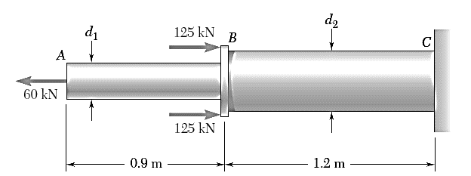

Fig. 1

Q2. Draw the shear force and bending moment diagrams for the overhanging beam carrying uniformly distributed load of 2 kN/m over the entire length and a point load of 2 kN as shown in Fig. 2. Locate the point of contra-flexure.



Fig. 2