1
MASUKKAN TAJUK BAB
Masukkan Nama Penulis

1.1 PENGENALAN (Bidang Sains Sosial Tidak Perlu Pernomboran)
Masukkan teks

1.2 MASUKKAN SUB TOPIK
Masukkan teks

1.2.1 Masukkan Sub-Sub Topik
Masukkan teks

1.2.1.1 Masukkan Sub kepada Sub-Sub Topik
Contoh teks mengandungi jadual:

Table 1(a) Statistics for the dataset (balanced data)
Category | Dataset | BWS | AWS | Difference
Multi-class classification | Diseases | 6081 | 2693 | 3388
Binary classification | Cancer | 4070 | 1721 | 2349
Binary classification | Hepatitis | 4127 | 1717 | 2410
Binary classification | HIV/AIDS | 4227 | 1719 | 2508
Binary classification | Thyroid | 4131 | 1696 | 2435

Sambungan teks…

1.2.1.2 Masukkan Sub kepada Sub-Sub Topik
Masukkan teks

Contoh teks mengandungi rajah/graf/carta/peta:

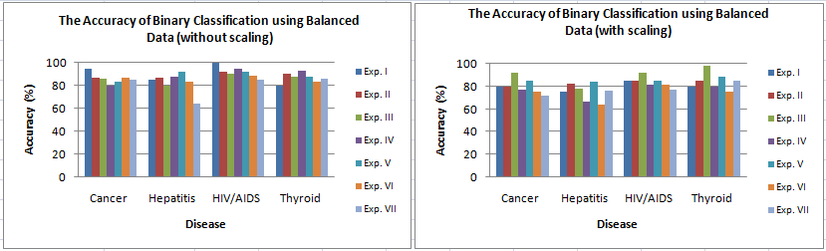
Figure 1 The accuracy of binary classification
(balanced data)
Sambungan teks…

1.2.2 Masukkan Sub-Sub Topik
Masukkan teks

1.2.2.1 Masukkan Sub kepada Sub-Sub Topik
Masukkan teks

1.2.2.2 Masukkan Sub kepada Sub-Sub Topik
Masukkan teks

1.2.3 Masukkan Sub-Sub Topik
Masukkan teks

1.2.3.1 Masukkan Sub kepada Sub-Sub Topik
Masukkan teks

1.2.3.2 Masukkan Sub kepada Sub-Sub Topik
Masukkan teks

RUJUKAN

Masukkan Senarai Rujukan
Contoh:

Chang, C.-C. and Lim, C.-J. 2001. LIBSVM: a library for support vector machines. Software available at http://www.csie. ntu.edu.tw/~cjlin/libsvm.
Cohen, A.M and Hersh, W.R. 2005. A Survey of Current Work in Biomedical Text Mining. Briefings in Bioinformatics, 6(1): 57-71.
Couto, F.M., Martins, B. and Silva, M.J. 2004. Classifying Biological Articles using Web Resources. Proceeding of the 2004 ACM Symposium on Applied Computing, pp.111-115.
Dollah, R. and Aono, M. 2008. Classifying Biomedical Text Abstracts using Binary and Multi-class Support Vector Machine, The 22nd Annual Conference of the Japanese Society for Artificial Intelligence, Hokkaido.
Ho, C. Y. and Lam, W. 1998. Automatic discovery of document classification knowledge from text databases. available at http://citeseer.ist.psu.edu/310941.html.
Leonard, J.E. Colombe, J.B. and Joshua, L.L. 2002. Finding Relevant References to Genes and Proteins in Medline using a Bayesian Approach. Bioinformatics, 18(11): 1515-1522.
Lewis, D.D. and Ringuette, M.A. 1994. Comparison of Two Learning Algorithms for Text Categorization. Proceeding of 3rd Annual Symposium on Document Analysis and Information Retrieval, Las Vegas, pp. 81-93.
Mahinovs, A. and Tiwari, A. 2005. Text Classification Method Review. Decision Engineering Report Series, Canfield University, UK.
Remeikis, N. Skucas, I. and Melninkaite, V. 2004. Hybrid Machine Learning Approach for Text Categorization. International Journal of Computational Intelligence, 1(1): 63-67.
Soucy, P. and Mineau, G.W. 2005. Beyond TFIDF Weighting for Text Categorization in the Vector Space Model, International Joint Conferences on Artificial Intelligence, Scotland, pp. 1130-1135.
Wiener, E.D., Pedersen, J.O. and Weigend, A.S. 1995. A Neural Network Approach to Topic Spotting. Proceedings of SDAIR-95, 4th Annual Symposium on Document Analysis and Information Retrieval, Las Vegas, pp. 317-333.

