UNIVERSITI TEKNOLOGI MALAYSIA

TEST 2 1 HOUR

ENGINEERING ECONOMY

QUESTION

i. Look up the numerical value for the following factors from the interest tables.

1. ( *P*_*F* ,6%,8)

2. ( *A*_*P* ,10%,10)

3. ( *A*_*G* ,15%,20)

4. ( *A*_*F* ,2%,30)

5. ( *P*_*G* ,35%,15)

[10 MARKS]

ii. Pyramid Energy requires that for each of its offshore wind power generators $5000 per year be placed into a capital reserve fund to cover unexpected major rework on fi eld equipment. In one case, $5000 was deposited for 15 years and covered a rework costing $100,000 in year 15. What rate of return did this practice provide to the company? Solve by hand and spreadsheet.

[10 MARKS]

iii. A family that won a $100,000 prize on America’s Funniest Home Videos decided to put one-half of the money in a college fund for their child who was responsible for the prize. If the fund earned interest at 6% per year, how much was in the account14 years after it was started?

[10 MARKS]

iv. CGK Rheo systems makes high-performance rotational viscometers capable of steady shear and yield stress testing in a rugged, compact footprint. How much could the company afford to spend now on new equipment in lieu of spending $200,000 one year from now and $300,000 three years from now, if the company uses an interest rate of 15% per year?

[20 MARKS]

**CASE STUDY**

**TIME MARCHES ON; SO DOES THE INTEREST RATE**

**Background**

During the last week, Sundara has read about different situations that involve money, interest rate, and different amounts of time. She has gotten interested in the major effects that time and interest rates have on the amount of money necessary to do things and the signifi cant growth in the amount of money when a large number of years are considered. In all cases, the interest focuses on the amount of money at the end of the time period.

**Information**

The four situations are described here.

1. Manhattan Island was purchased in 1626 for $24. After 385 years in 2011, at 6% per year compounded interest, the current value must be very large.

B. At the age of 22, if she saved only $2000 per year for the next 10 years (starting next year) and made a return of 6% per year, by today’s standards, she would have accumulated a nice sum at the age of 70.

C. A corporation invested $2 million in developing and marketing a new product in 1945 (just after World

War II, this was a lot of money) and has made a steady net cash fl ow of $300,000 per year for some 65 years. Sundara estimated the annual rate of return must be quite good, especially given that she is lucky to earn 4% per year on her own investments these days.

D. A friend who is not good with money, went to a pawn shop and borrowed $200 for one week and paid $30 in interest. Sundara thought this might be a pretty good deal, in case she ever ran low on cash. However, she did not know whether the interest was simple or compounded monthly, and how much

**Case Study Exercises**

1. What is the annual interest rate for each situation? Include both the annual simple and the compound rates for situation D.

2. Calculate and observe the total amount of money involved in each situation at the end of the time periods compared to the starting amount. Is the ending amount larger or smaller than you would expect it to be prior to making any computations?

3. Think of a situation for yourself that may be similar toany of those above. Determine the interest rate, the time period, and the starting and ending amounts of money.

**EXAMPLE 3.1**

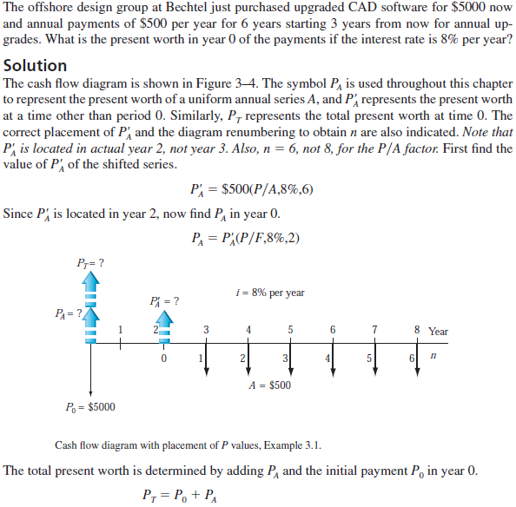



**EXAMPLE 3.2**

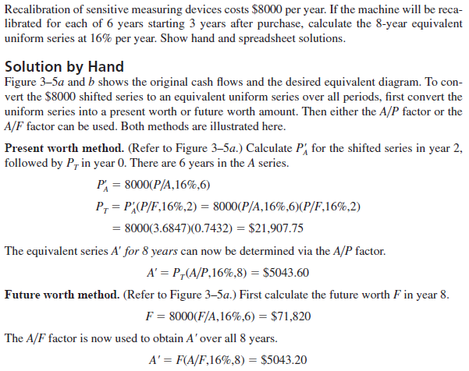

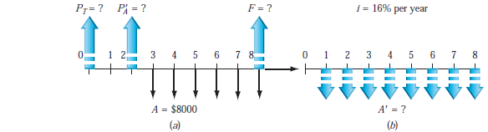

**EXAMPLE 3.3**

