UNIVERSITI TEKLNOLOGI MALAYSIA

WORK STANDADRDIZATION (FRSB 2403)

CASE STUDY 19 Dec 2021

Case 1

Though a few states in Malaysia have excess energy, majority of states, rural areas are deprived of sufficient electricity in Malaysia. How can Malaysia overcome this. What are the steps government should take.

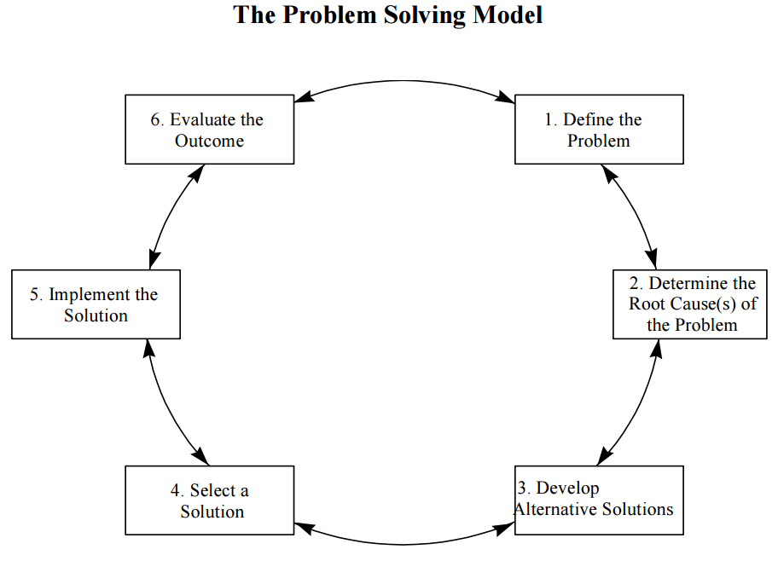

Case 2

Design a renewable electrical energy generation systems for remote area in Royal Belum Malaysia using Process Design.
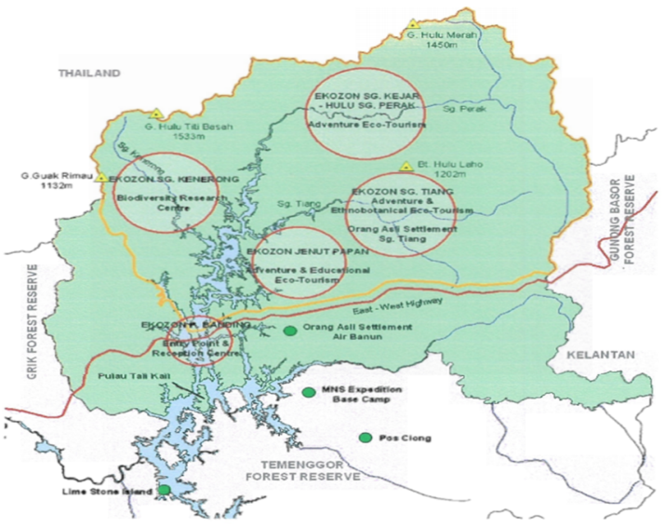
4 eco-tourism zones; Pulau Banding, Jenut Papan, Sungai Kenerang, Sungai Tiang and Sungai Kejar are the potential spots for tourists
Exercise – Part 1

- At each table, choose a waste and create a problem statement
- Brainstorm on who should be on the team
- Brainstorm on what Current Condition data should be collected
- present their work

“Fishbone: Solar panel damage

- At each table, brainstorm on goals for your task
- Brainstorm on what is in scope and what is out of scope
- present their work

