**CASE STUDY 2**

**Control Chart**

The control chart is a graph used to study how a process changes over time. Data are plotted in time order. A control chart always has a central line for the average, an upper line for the upper control limit and a lower line for the lower control limit. These lines are determined from historical data. By comparing current data to these lines, you can draw conclusions about whether the process variation is consistent (in control) or is unpredictable (out of control, affected by special causes of variation).

Control charts for variable data are used in pairs. The top chart monitors the average, or the centering of the distribution of data from the process. The bottom chart monitors the range, or the width of the distribution. If your data were shots in target practice, the average is where the shots are clustering, and the range is how tightly they are clustered. Control charts for attribute data are used singly.

1. When to Use a

* When controlling ongoing processes by finding and correcting problems as they occur.
* When predicting the expected range of outcomes from a process.
* When determining whether a process is stable (in statistical control).
* When analyzing patterns of process variation from special causes (non-routine events) or common causes (built into the process).
* When determining whether your quality improvement project should aim to prevent specific problems or to make fundamental changes to the process.

1. Template

See a sample control chart and create your own with the [control chart template](http://asq.org/learn-about-quality/data-collection-analysis-tools/overview/asq-control-chart.xls) (Excel, 973 KB).*

1. Control Chart Basic Procedure
2. Choose the appropriate control chart for your data.
3. Determine the appropriate time period for collecting and plotting data.
4. Collect data, construct your chart and analyze the data.
5. Look for “out-of-control signals” on the control chart. When one is identified, mark it on the chart and investigate the cause. Document how you investigated, what you learned, the cause and how it was corrected.

**Out-of-control signals**

* + A single point outside the control limits. In Figure 1, point sixteen is above the UCL (upper control limit).
  + Two out of three successive points are on the same side of the centerline and farther than 2*σ*from it. In Figure 1, point 4 sends that signal.
  + Four out of five successive points are on the same side of the centerline and farther than 1*σ*from it. In Figure 1, point 11 sends that signal.
  + A run of eight in a row are on the same side of the centerline. Or 10 out of 11, 12 out of 14 or 16 out of 20. In Figure 1, point 21 is eighth in a row above the centerline.
  + Obvious consistent or persistent patterns that suggest something unusual about your data and your process.

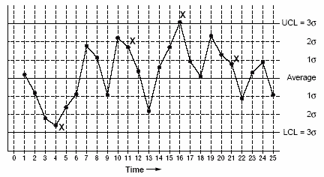

**Figure 1**Control Chart: Out-of-Control Signals

1. Continue to plot data as they are generated. As each new data point is plotted, check for new out-of-control signals.
2. When you start a new control chart, the process may be out of control. If so, the control limits calculated from the first 20 points are conditional limits. When you have at least 20 sequential points from a period when the process is operating in control, recalculate control limits.

**Cause–and–Effect Diagram, Ishikawa Diagram**

Variations: cause enumeration diagram, process fishbone, time–delay fishbone, CEDAC (cause–and–effect diagram with the addition of cards), desired–result fishbone, reverse fishbone diagram

The fishbone diagram identifies many possible causes for an effect or problem. It can be used to structure a brainstorming session. It immediately sorts ideas into useful categories.

1. When to Use a Fishbone Diagram

* When identifying possible causes for a problem.
* Especially when a team’s thinking tends to fall into ruts.

1. Fishbone Diagram Procedure

Materials needed: flipchart or whiteboard, marking pens.

1. Agree on a problem statement (effect). Write it at the center right of the flipchart or whiteboard. Draw a box around it and draw a horizontal arrow running to it.
2. Brainstorm the major categories of causes of the problem. If this is difficult use generic headings:
   * Methods
   * Machines (equipment)
   * People (manpower)
   * Materials
   * Measurement
   * Environment
3. Write the categories of causes as branches from the main arrow.
4. Brainstorm all the possible causes of the problem. Ask: “Why does this happen?” As each idea is given, the facilitator writes it as a branch from the appropriate category. Causes can be written in several places if they relate to several categories.
5. Again ask “why does this happen?” about each cause. Write sub–causes branching off the causes. Continue to ask “Why?” and generate deeper levels of causes. Layers of branches indicate causal relationships.
6. When the group runs out of ideas, focus attention to places on the chart where ideas are few.
7. Fishbone Diagram Example

This fishbone diagram was drawn by a manufacturing team to try to understand the source of periodic iron contamination. The team used the six generic headings to prompt ideas. Layers of branches show thorough thinking about the causes of the problem.

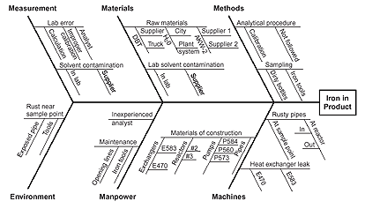

**Fishbone Diagram Example**

For example, under the heading “Machines,” the idea “materials of construction” shows four kinds of equipment and then several specific machine numbers.

Note that some ideas appear in two different places. “Calibration” shows up under “Methods” as a factor in the analytical procedure, and also under “Measurement” as a cause of lab error. “Iron tools” can be considered a “Methods” problem when taking samples or a “Manpower” problem with maintenance personnel.

**Histogram**

A frequency distribution shows how often each different value in a set of data occurs. A histogram is the most commonly used graph to show frequency distributions. It looks very much like a bar chart, but there are important differences between them.

1. When to Use a

* When the data are numerical.
* When you want to see the shape of the data’s distribution, especially when determining whether the output of a process is distributed approximately normally.
* When analyzing whether a process can meet the customer’s requirements.
* When analyzing what the output from a supplier’s process looks like.
* When seeing whether a process change has occurred from one time period to another.
* When determining whether the outputs of two or more processes are different.
* When you wish to communicate the distribution of data quickly and easily to others.

1. Histogram Construction
2. Collect at least 50 consecutive data points from a process.
3. Use the [histogram worksheet](http://asq.org/learn-about-quality/data-collection-analysis-tools/overview/histogram-worksheet.html)to set up the histogram. It will help you determine the number of bars, the range of numbers that go into each bar and the labels for the bar edges. After calculating *W*in step 2 of the worksheet, use your judgment to adjust it to a convenient number. For example, you might decide to round 0.9 to an even 1.0. The value for *W*must not have more decimal places than the numbers you will be graphing.
4. Draw x- and y-axes on graph paper. Mark and label the y-axis for counting data values. Mark and label the x-axis with the *L*values from the worksheet. The spaces between these numbers will be the bars of the histogram. Do not allow for spaces between bars.
5. For each data point, mark off one count above the appropriate bar with an X or by shading that portion of the bar.
6. Histogram Analysis

* Before drawing any conclusions from your histogram, satisfy yourself that the process was operating normally during the time period being studied. If any unusual events affected the process during the time period of the histogram, your analysis of the histogram shape probably cannot be generalized to all time periods.
* Analyze the meaning of your histogram’s shape.

**Pareto diagram, Pareto analysis**

Variations: weighted Pareto chart, comparative Pareto charts

A Pareto chart is a bar graph. The lengths of the bars represent frequency or cost (time or money), and are arranged with longest bars on the left and the shortest to the right. In this way the chart visually depicts which situations are more significant.

1. When to Use a Pareto Chart

* When analyzing data about the frequency of problems or causes in a process.
* When there are many problems or causes and you want to focus on the most significant.
* When analyzing broad causes by looking at their specific components.
* When communicating with others about your data.

1. Pareto Chart Procedure
2. Decide what categories you will use to group items.
3. Decide what measurement is appropriate. Common measurements are frequency, quantity, cost and time.
4. Decide what period of time the Pareto chart will cover: One work cycle? One full day? A week?
5. Collect the data, recording the category each time. (Or assemble data that already exist.)
6. Subtotal the measurements for each category.
7. Determine the appropriate scale for the measurements you have collected. The maximum value will be the largest subtotal from step 5. (If you will do optional steps 8 and 9 below, the maximum value will be the sum of all subtotals from step 5.) Mark the scale on the left side of the chart.
8. Construct and label bars for each category. Place the tallest at the far left, then the next tallest to its right and so on. If there are many categories with small measurements, they can be grouped as “other.”

Steps 8 and 9 are optional but are useful for analysis and communication.

1. Calculate the percentage for each category: the subtotal for that category divided by the total for all categories. Draw a right vertical axis and label it with percentages. Be sure the two scales match: For example, the left measurement that corresponds to one-half should be exactly opposite 50% on the right scale.
2. Calculate and draw cumulative sums: Add the subtotals for the first and second categories, and place a dot above the second bar indicating that sum. To that sum add the subtotal for the third category, and place a dot above the third bar for that new sum. Continue the process for all the bars. Connect the dots, starting at the top of the first bar. The last dot should reach 100 percent on the right scale.
3. Pareto Chart Examples

Example #1 shows how many customer complaints were received in each of five categories.

Example #2 takes the largest category, “documents,” from Example #1, breaks it down into six categories of document-related complaints, and shows cumulative values.

If all complaints cause equal distress to the customer, working on eliminating document-related complaints would have the most impact, and of those, working on quality certificates should be most fruitful.

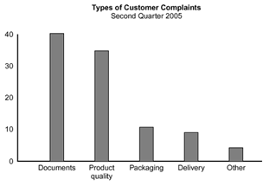  
Example #1

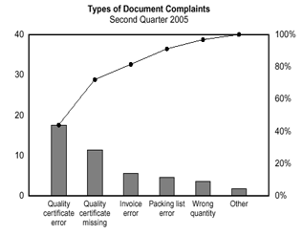  
Example #2

### CASE STUDY 2

### Micro-hydro Power plants (5 kW - 100 kW)

Solution to the power needs of small communities. Small hydraulic sites present a variety of economic advantages. Provide power for industrial, agricultural and domestic uses. Cost effective source for the rural communities which is cannot be fed by the national grid.



Schematic diagram of micro-hydro power plant