

UNIVERSITI TEKNOLOGI MALAYSIA

FINAL EXAMINATION SEMESTER II
2012/2013 SESSION

COURSE CODE : UHB 2422 / ULAB 2112

COURSE : ADVANCED ENGLISH FOR ACADEMIC COMMUNICATION

PROGRAMME : ALL PROGRAMMES

DURATION : 2 HOURS 30 MINUTES

DATE : JUNE 2013

MARKS : 40

INSTRUCTIONS TO CANDIDATES:

Answer the question in the answer booklet provided.

THIS EXAMINATION PAPER CONSISTS OF 6 PRINTED PAGES
(INCLUDING THIS PAGE).

Instructions:
Read the situation below and complete the task given using the primary and secondary sources provided.

Situation
The World Health Organization (WHO) ranked Malaysia as the sixth in Asia and first in Southeast Asia with the highest adult obesity rate. Almost one in two Malaysians is either overweight or obese. As obesity becomes a disturbing trend in Malaysia, diseases associated with obesity are likely to increase even more. Thus, a research team was set up by the Health Ministry to investigate this matter. A total of 5000 respondents were surveyed in this study. Results from the survey are presented in the following pages.

Task
You are the head of the research team. Write a report of five to seven pages using information from all the primary data given and your background knowledge. You should also use relevant secondary data from the two excerpts provided. Your report should include the following headings:

INTRODUCTION (background, objectives, scope and significance of study)
METHODOLOGY (respondents, instruments and research procedure)
FINDINGS AND DISCUSSION
CONCLUSION
RECOMMENDATIONS

Note: Marks will be deducted for direct lifting of sentences from the excerpts without proper in-text citation.

PRIMARY DATA

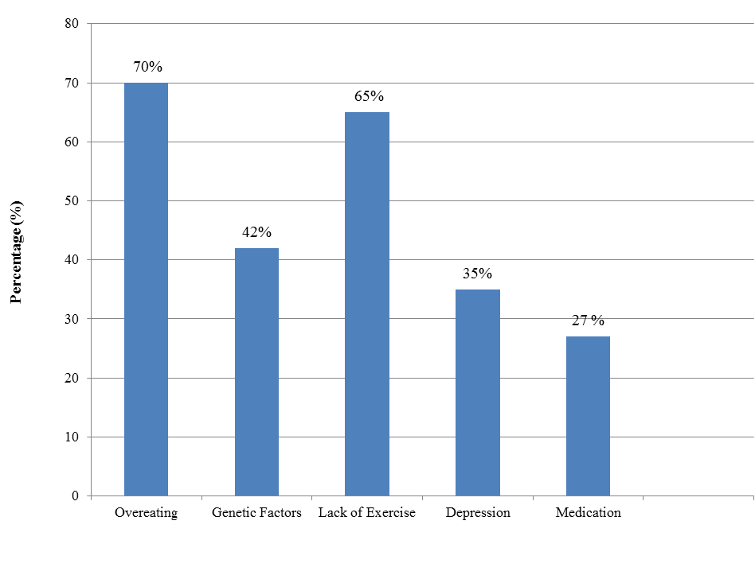
Contributing Factors

Figure 1: Common Contributing Factors for Obesity

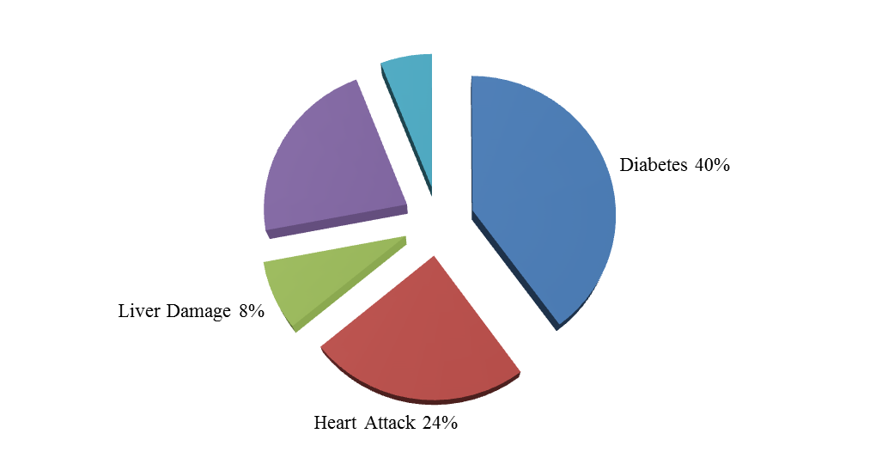
Stroke 6%
High Blood Pressure
22%
Figure 2: Health Effects of Obesity

Table 1: Ways to Overcome Obesity

Suggestions | Percentage  (%)
Reduce food portion per meal | 80
Maintain healthy diet | 75
Exercise regularly | 52
Drink plenty of plain water | 37
Reduce fast food intake | 65

SECONDARY DATA

Excerpt 1

Loh, F. F. (2012). Obese Children Face Liver and Cancer Danger, Says Foundation.

The Star July 22.Retrieved on October 1, 2012 from http://thestar.com.my/news/story.asp?file=/2012/7/22/nation/11710525&sec=nation

PETALING JAYA: Obese children face a high risk of suffering from liver damage or cancer as they get older unless parents intercept the problem early. Malaysian Liver Foundation president Tan Sri Dr Ismail Merican, quoting Malaysian Association for the Study of Obesity, said that as many as 15 per cent of Malaysian toddlers were overweight or obese while 30 per cent of primary school children faced the problem.
“If the non-alcoholic fatty liver problem is not addressed, these children can end up as obese adults and prone to all kinds of diseases such as liver damage, diabetes, hypertension and getting a stroke at a younger age,” he said in an interview in conjunction with the World Hepatitis Day campaign recently.
Dr Ismail said that fatty liver would become a problem when it reaches the non-alcoholic steatohepatitis stage, where inflammation of liver occurs and can lead to scarring and subsequently cirrhosis or liver cancer. “Fatty liver can be reversed but not liver cirrhosis,” he said. Dr Ismail urged parents to be good role models for their children’s sake.
Many children were overweight because they ate outside food with high fat, sugar and salt content but did not expend the calories by exercising, he said.
“Parents should give their children a balanced diet and add more fruits and vegetables into their food, use less sugar and salt and complete it with physical activities,” he said. Dr Ismail said overweight children also suffered from poor self-esteem and parents should not push them too hard. Instead, they should find activities the children like to be involved in so they would have a sense of purpose.
Parents were also encouraged to do activities with their children, he said. Obesity in Malaysia is the worst among Asian countries. About 94 per cent of obese persons with body mass index (BMI) more than 30 have fatty liver while 67 per cent of those with BMI 25 to 30 also have the condition. About 25 per cent of normal weight patients also have fatty liver.

Excerpt 2
Samy, F. A. (2010). Malaysians Getting Obese – by Eating Too Heavily at Night. The Star April 11. Retrieved on October 1, 2012 from
http://thestar.com.my/news/story.asp?sec=nation&file=/2010/4/11/nation/6034589

PETALING JAYA: More Malaysians are keeping awake till late to indulge in what is becoming a top national pastime, tucking it in at 24-hour eating restaurants. Yes, we are practically eating round-the-clock. These shops have sprouted up all over the country to satisfy the cravings of Malaysians who are gorging on calorie-packed late night meals with hardly a care and getting obese in the process.
Health Minister Datuk Seri Liow Tiong Lai is obviously a very worried man, with more Malaysians at risk of being seriously ill due to uncontrollable eating. “The habit of eating unbalanced diet and eating late at night has to change,’’ he cautioned. “In the past, we used to have two meals. These days, we are eating five to six times daily with late-night supper’’ he said after launching the Malaysian Council for Obesity Prevention (MCOM) here yesterday. MCOM, which comprises 13 professional bodies and NGOs, was set up to help the government counter the problem of obesity in the country.
The minister, an avowed vegetarian, spoke of another worrying trend – meat is fast becoming a staple-diet here. A diet rich in red meat causes high cholesterol which leads to cardio-vascular disease. Being overweight and obese, he said, would lead to chronic diseases such as diabetes, high blood pressure, heart disease and even cancer. According to statistics, 14.9 per cent and 43 per cent of Malaysians aged above 30 suffer from diabetes and hypertension respectively, with 20.7 per cent of adults over 18 suffering from high cholesterol.
Liow said 300 nutritionists would be employed to serve at government clinics nationwide to help tackle obesity problems by creating awareness on the dangers of unhealthy eating. Malaysian Council for Obesity Prevention (MCOM) president Jong Koi Chong echoed the minister’s concerns, saying the unhealthy eating trend was becoming a major problem.“Our metabolic rate is very low at night making it easy for fat to accumulate in the body."Most 24-hour restaurants serve food that is high in fat, calories and cholesterol. Sadly, more of our young are picking up bad eating habits from adults,’’ he added.

