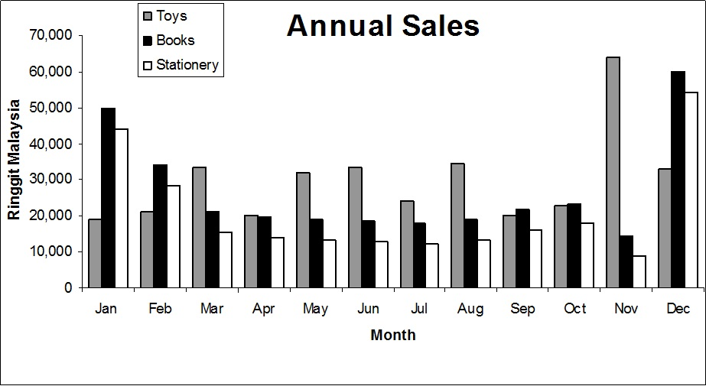
Figure 1 shows the annual sales of a retail chain store for the year 2006. In general, the sales of books and stationery showed similar trend. It can be seen that both sales of books and stationery were at their peak in January and December. It started very encouraging in January but dropped gradually in three months then remained constant for five months onwards. It started to pick up its sales in September and October but showed a sudden drop in November. However, the sales increased significantly in December. Meanwhile, the sales of toys fluctuated across the year but there is an apparent increase of sales in November. The sales trend of toys, books and stationery is closely related to school term in Malaysia. December and January are the months where parents are busy preparing their children’s school needs which translated in the significant rise in sales of books and stationery. Besides that, the rise in sales of toys in November is because of school holidays. In conclusion, the sales of toys, books and stationery depended so much on school term which explains the significant increase of books and stationery sales in January and December and toys in November. (199 words)

